Answer Sheet – Design Question 3 (2012 Paper)
Information Kiosk
Candidates may answer any specification point in either graphical form or by annotation. No marks are awarded for the quality of graphical communication.
- allow for information to be input (1) e.g. keyboard / voice / mouse / track pad / joystick / buttons/ USB stick pen / internet link / touch screen / interactive whiteboard
- allow for information to be accessed (1) e.g. LCD / speaker / maps / lights / TV monitor / HD screen / e-paper / LED screen / touch screen / interactive whiteboard
- reflect the theme of transport (1) e.g. trains / buses / airplanes / bikes / cars
- be easily recognised from a distance within the museum (1) e.g. shapes / lights / profile / signage / use of colour /
- be suitable for both children and adults to use (1) e.g. size / split levels / adjustable seat / step up / table
- allow access to the inside of the information kiosk for maintenance (1) e.g. door / slide screen / access panel
- use appropriate materials available in the school workshop (1) e.g. specific named material (do not accept ‘wood/metal/plastic/card’)
- use manufacturing processes suitable for batch production (1) e.g. specific named process for batch production
Examiners Report Comment on Question:
A good spread of marks indicated that this question was accessible to most candidates although a number used a 'non-electronic' approach, designing basic leaflet holders or museum guides. However, this did not preclude them from gaining marks. A high number of candidates offered very similar designs and failed to gain the relevant marks on the second design idea. Graphic skills varied tremendously.

Question take from Pearson Edexcel GCSE In Design & Technology (5GR02) Paper 01 Unit 2: Knowledge and Understanding of Graphic Products – 2012
Example of candidate response:
Design idea 1
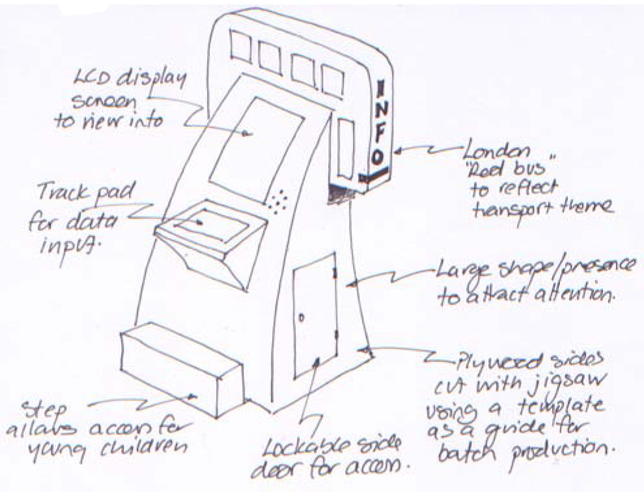

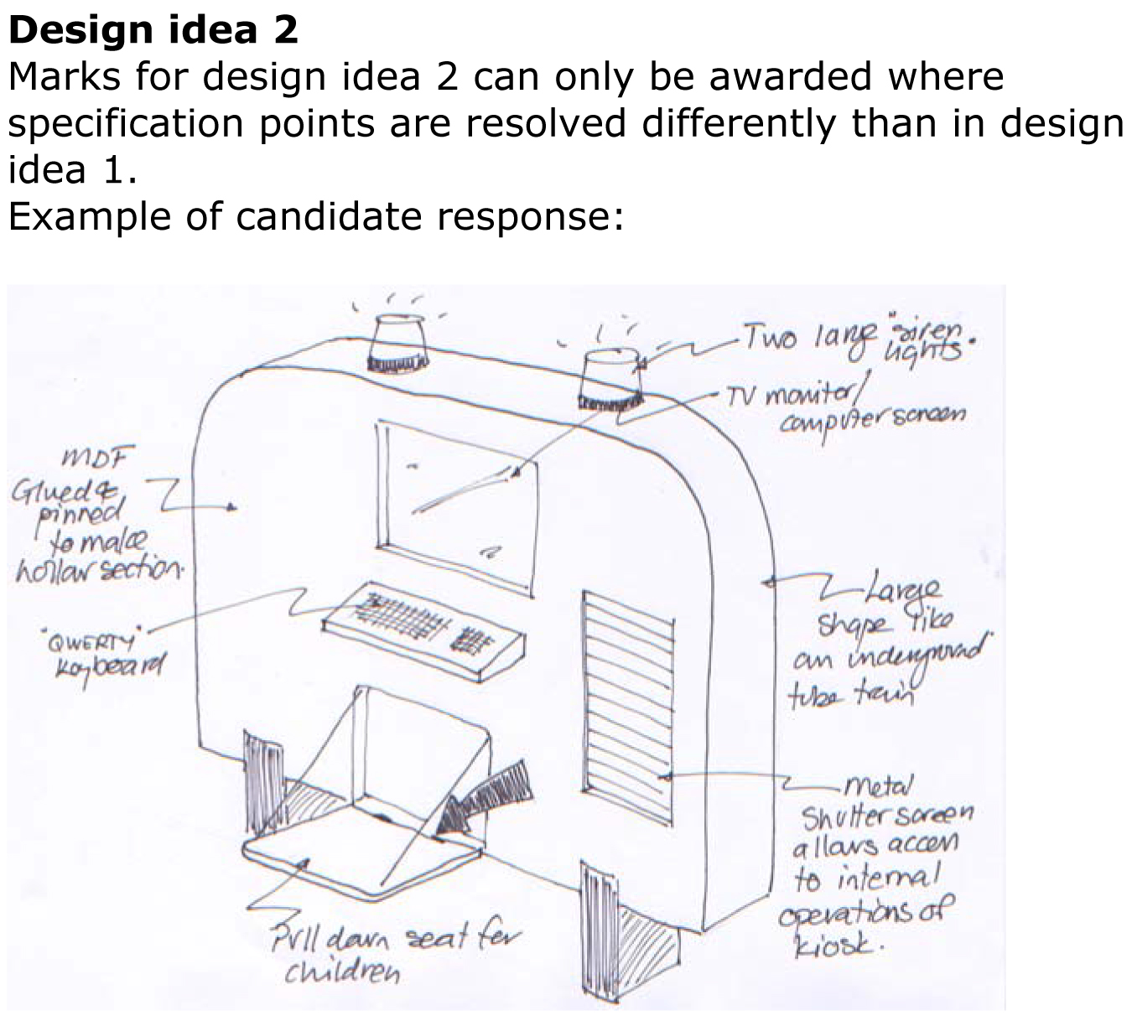

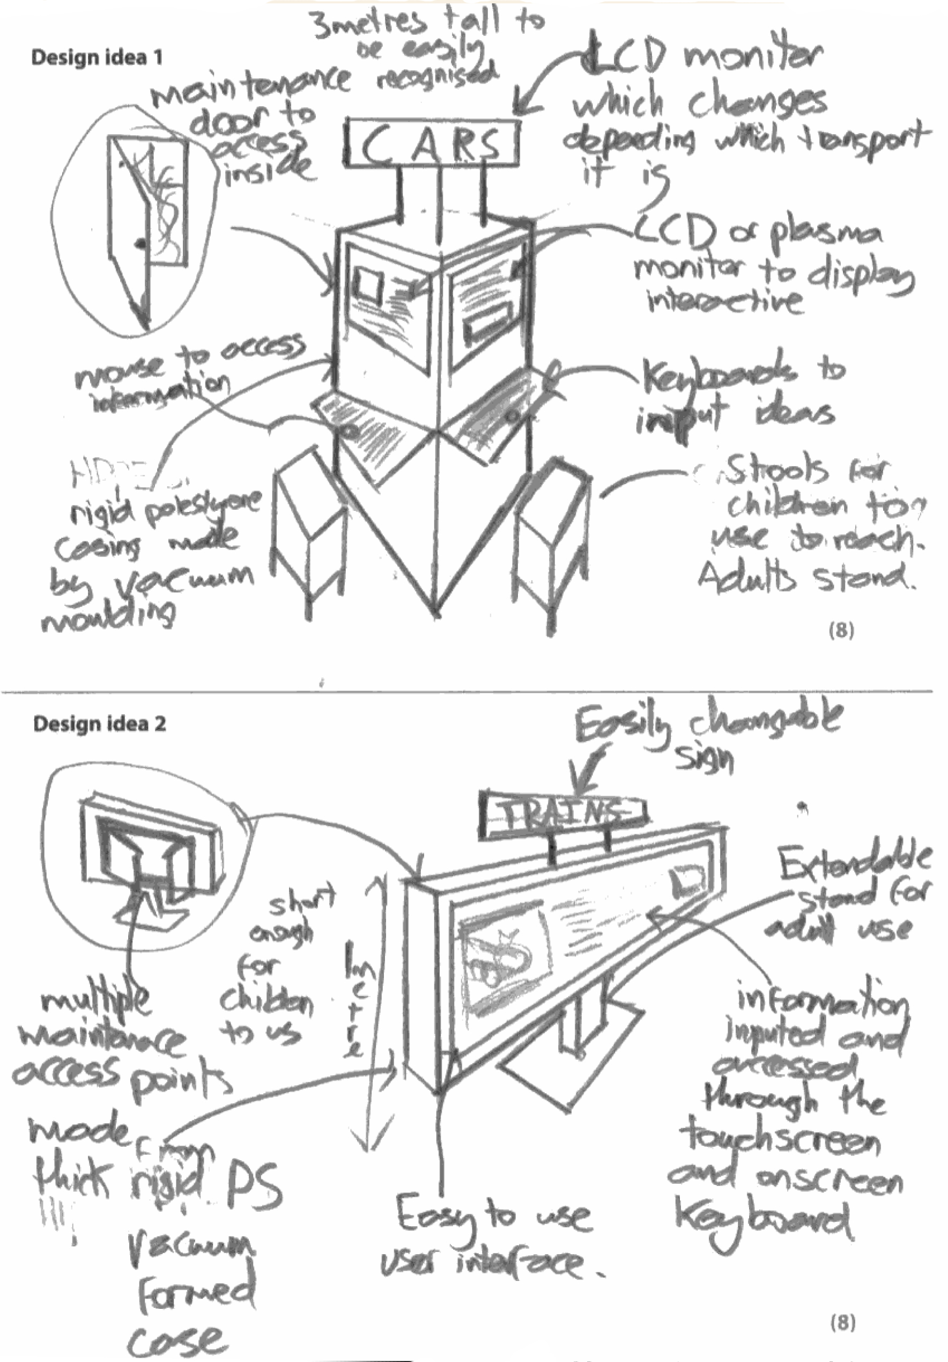

Examiners Comments
The candidate here has presented two different ideas to a very good standard overall. The designs are easy to see and the short, brief notes help to convey information and detail such as materials and processes.
Tip: Do not try to write too much, but keep notes brief and to the point. Do make sure that your second idea is different to the first one in that the design specification points are resolved in a different way to the way you have solved them for the design idea 1.

