Answer Sheet – Design Question 2 (2011 Paper)
Packaging for Cartoon Action Figure
1 mark should be awarded for evidence of each point of the specification resolved in the design. When an answer does not viably answer a specification point 0 marks. For each specification point with the element viably satisfied 1 mark. Candidates may answer any specification point in either graphical form or by annotation. No marks awarded for the quality of communication.
- The design should contain the two cartoon action figures (1), e.g. packaging should be able to accommodate two figures.
- The design should hold both figures securely whilst in transit (1), e.g. internal packaging to prevent contents from moving (blister pack, card net etc).
- The design should display the names of the two cartoon figures (1), e.g. package to include areas where graphics including the names ‘Poco’ and ‘Loco’ could be printed.
- The design should allow both figures to be clearly visible within the package (1), e.g. elements of the packaging must be transparent (acetate window, clear PVC blister etc).
- The design should allow the shop to either hang on racks or stack on shelves for display (1), e.g. include a ‘euro slot’ for hanging or be a shape that tessellates easily for stacking
- The design should allow customers to easily remove the figures when purchased (1), e.g. flaps and tucks indicated on a net, two halves of a clamshell/ blister etc.
- One specific material is indicated that is appropriate to the design (1), e.g. PVC for blister, folding boxboard for net etc Do not accept ‘plastic’ and ‘paper’
- One mass manufacturing process is indicated that is appropriate to the design (1), e.g. vacuum forming for a blister, die cutting for a net etc.
Examiners Report Comment on Question:
A wide range of appropriate designs were evidenced, from injection moulded carry cases to PVC tubes, but the most popular being a corrugated cardboard box style and a blister pack. Designs were generally communicated very well with some excellent sketching ability demonstrated. The use of detailed annotation was welcomed by examiners where sketches did not convey design intentions as well as they could.
Some candidates provided design ideas that were either identical or the second design was just a slight variation on the first. Centres are reminded that the second idea needs to be conceptually different to the first idea. This meant that candidates often failed to pick up as many marks as perhaps they could or should have. A small number of candidates provided just one idea, or two rather incomplete ideas.
In cases where candidates did not read the question thoroughly, a significant group failed to present design ideas that contained both of the action figures. Therefore, the first four specification points were extremely hard to achieve. Some candidates designed packaging for entirely different action figures altogether or designed the action figures themselves.
Valuable marks were dropped where a specification point(s) were left out completely. The method of holding the figures securely was not often clearly identified or communicated. Commonly, an appropriate specific material was not named (generic ‘plastic’ being unacceptable) or a mass production process relevant to the materials statement. Manufacturing processes can be for the actual 3D element such as ‘vacuum formed blister’ or a relevant printing process such as ‘offset lithography for the backing card’. Highly successful candidates drew up a specification checklist or numbered their annotation accordingly.
Question take from Pearson Edexcel GCSE In Design & Technology (5GR02) Paper 01 Unit 2: Knowledge and Understanding of Graphic Products – 2011
Example of candidate response:
Design idea 2
Design idea 1
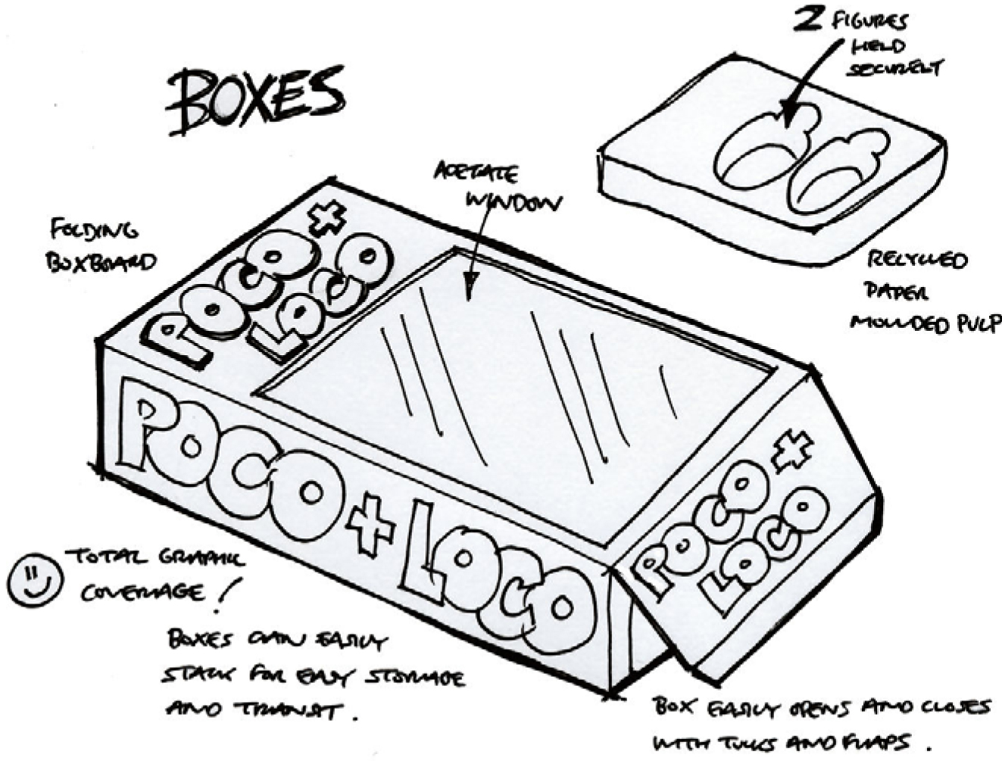

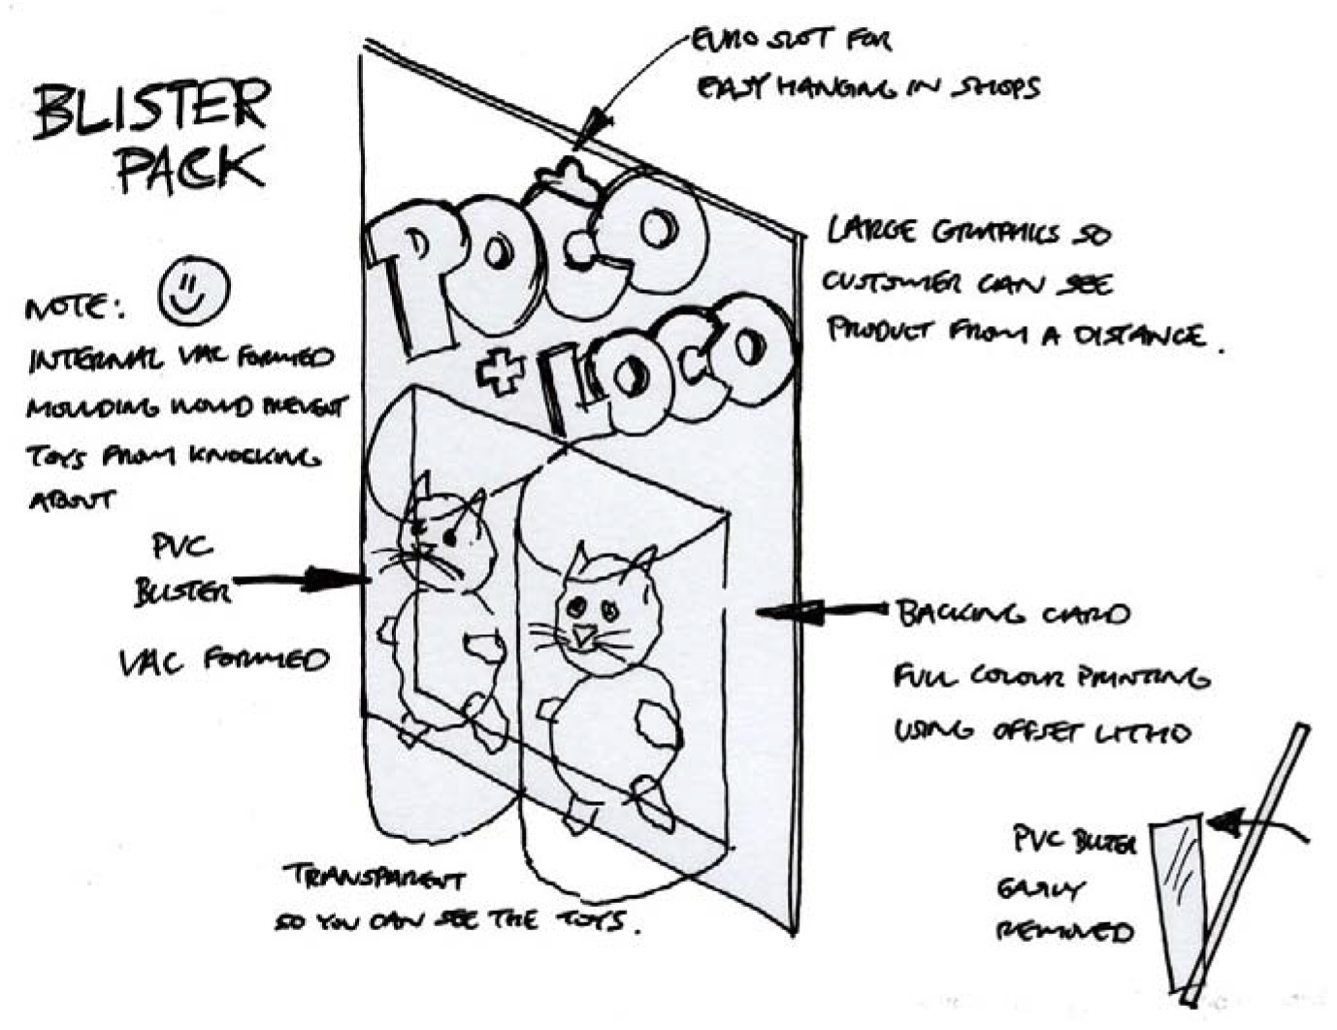

To score a mark for design idea 2, each specification point must be resolved in the second design idea but the second design idea must be technically/conceptually different in design and construction from the first and not a simple variation on a theme to score the mark. Use exactly the same criteria as design idea 1 to mark design idea 2.

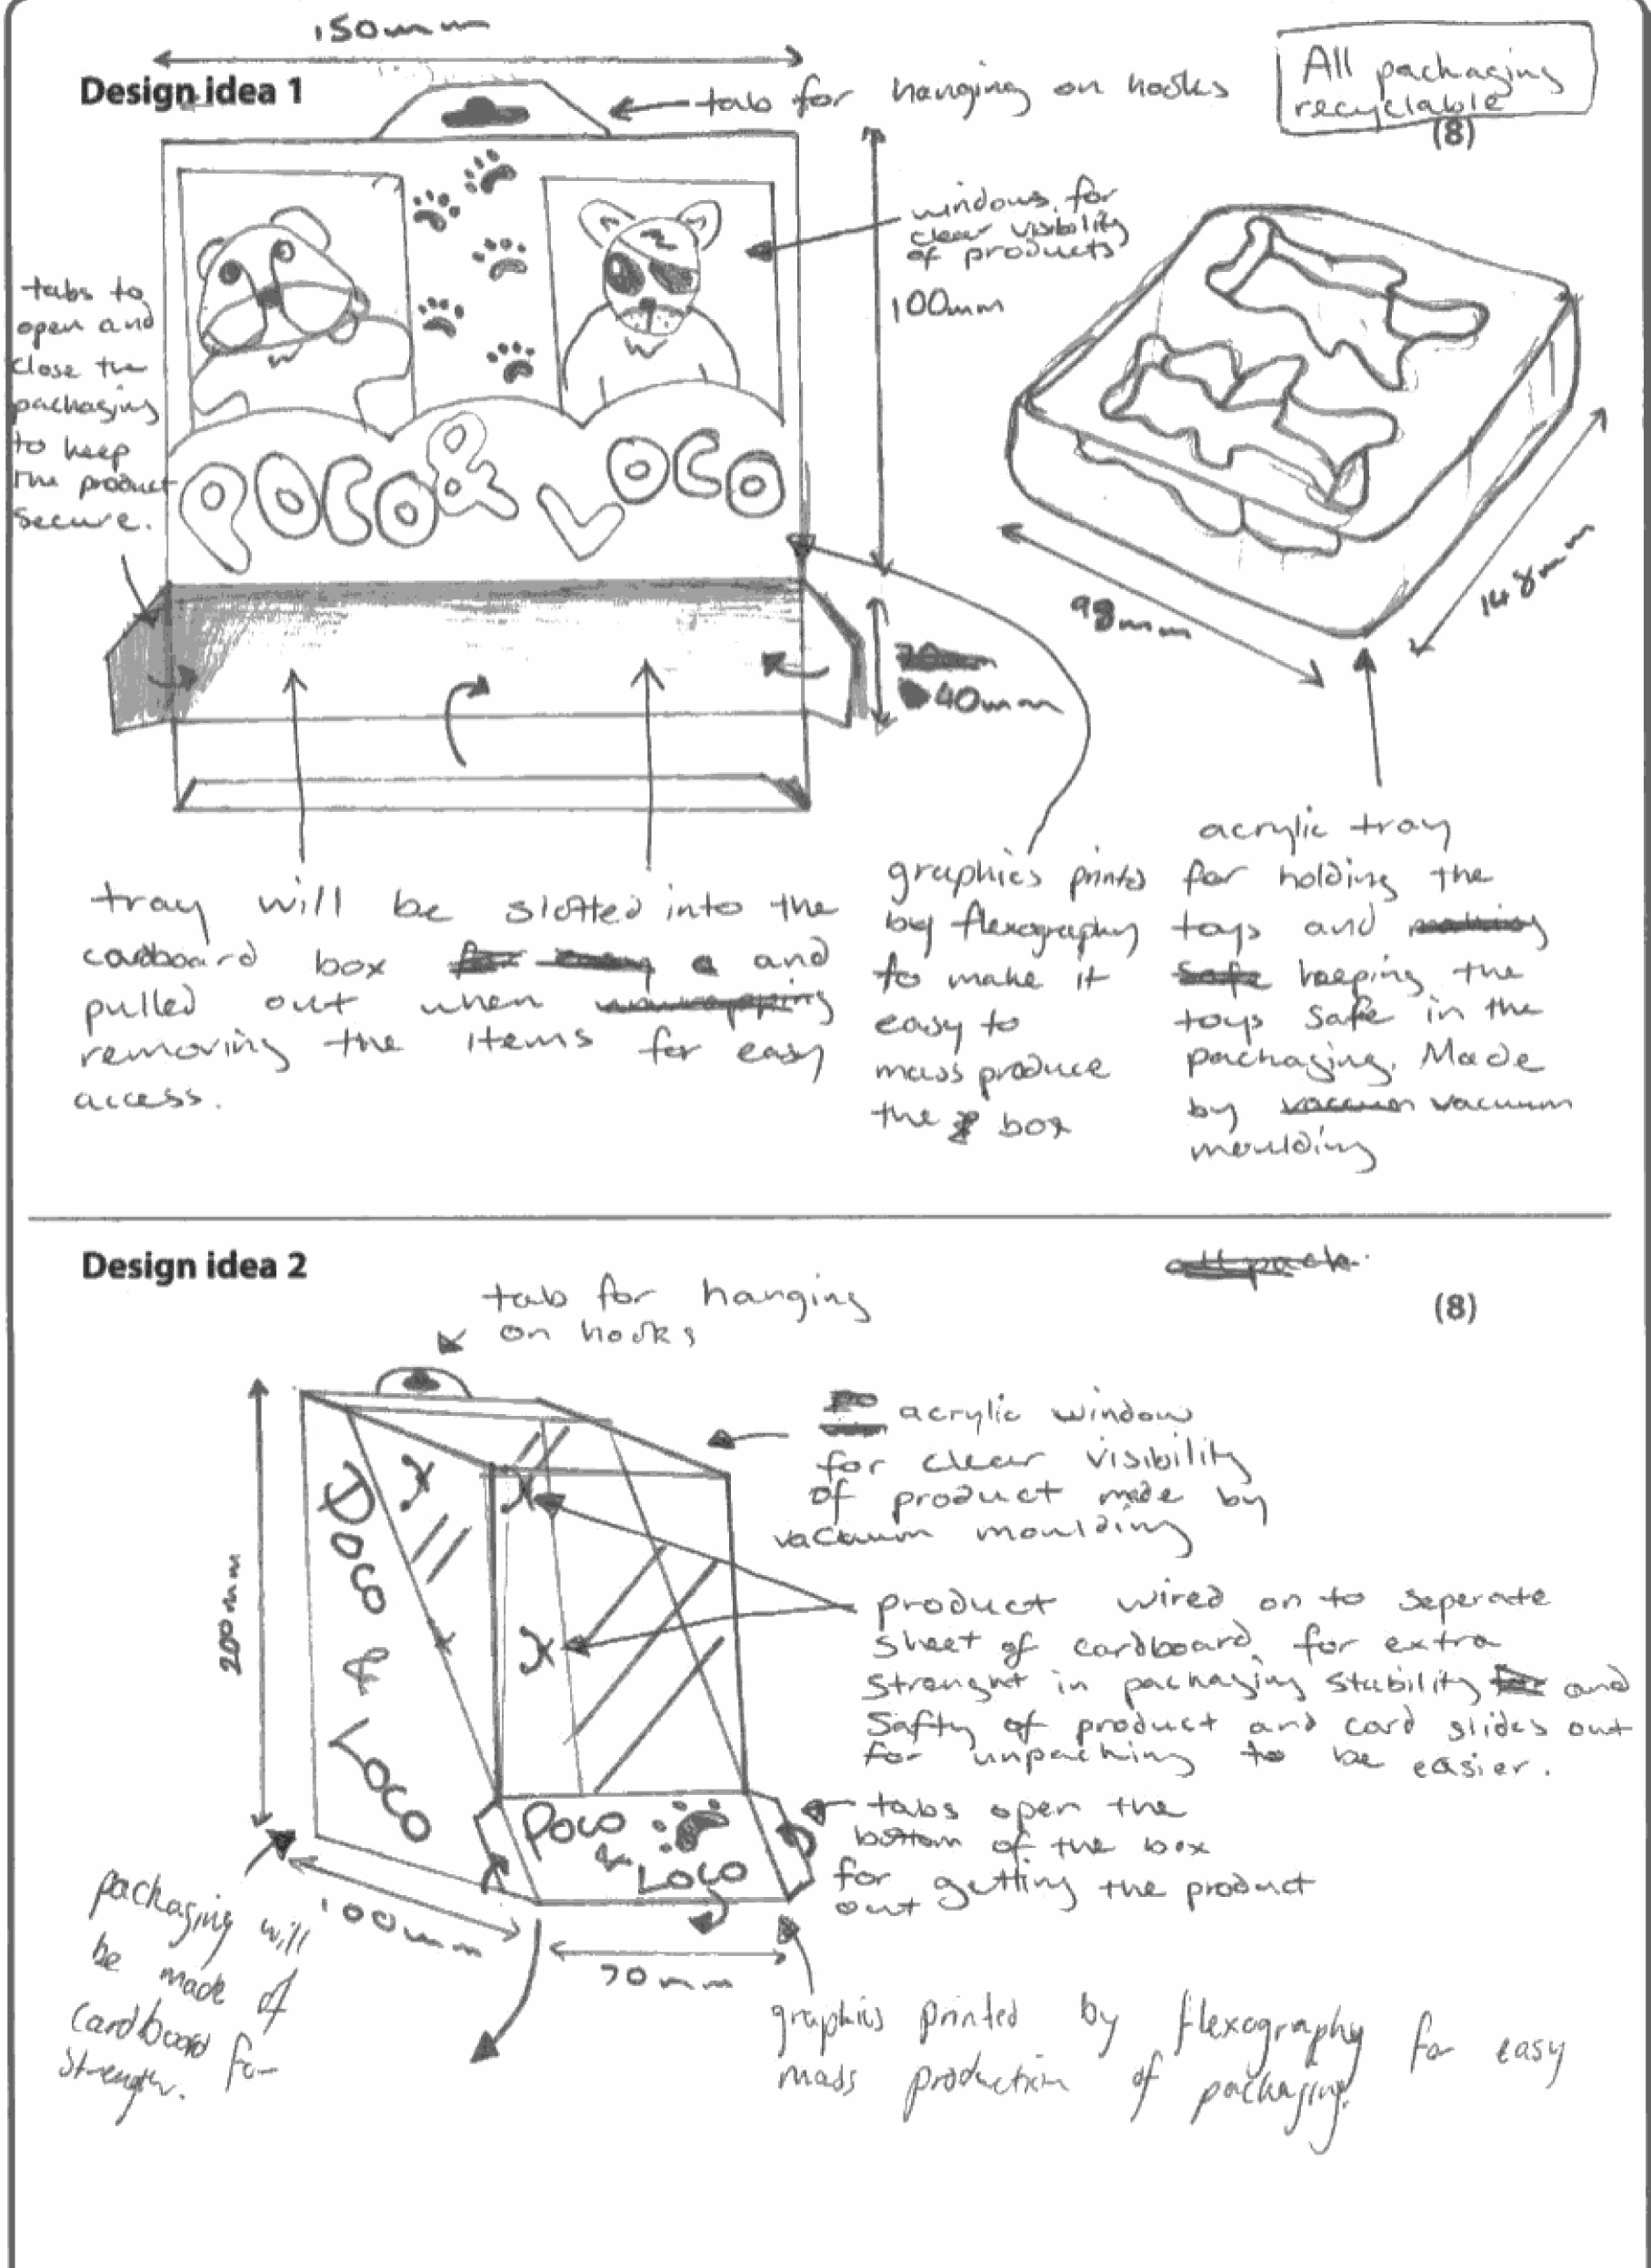

The specification clearly indicated that the packaging must be for the two figures illustrated - Poco and Loco. Unfortunately, this candidate could only gain a couple of marks out of the full 16 marks.

