Possible Areas of Development

5. Disused industrial area, west of the market square.

2. Railway Stockyards, northeast of the station.

3. Harchester Cattle Market, by the Harchester Arms.

4. Canal curve between the by-pass and Harchester road.

1. Waterhavens, by the canal

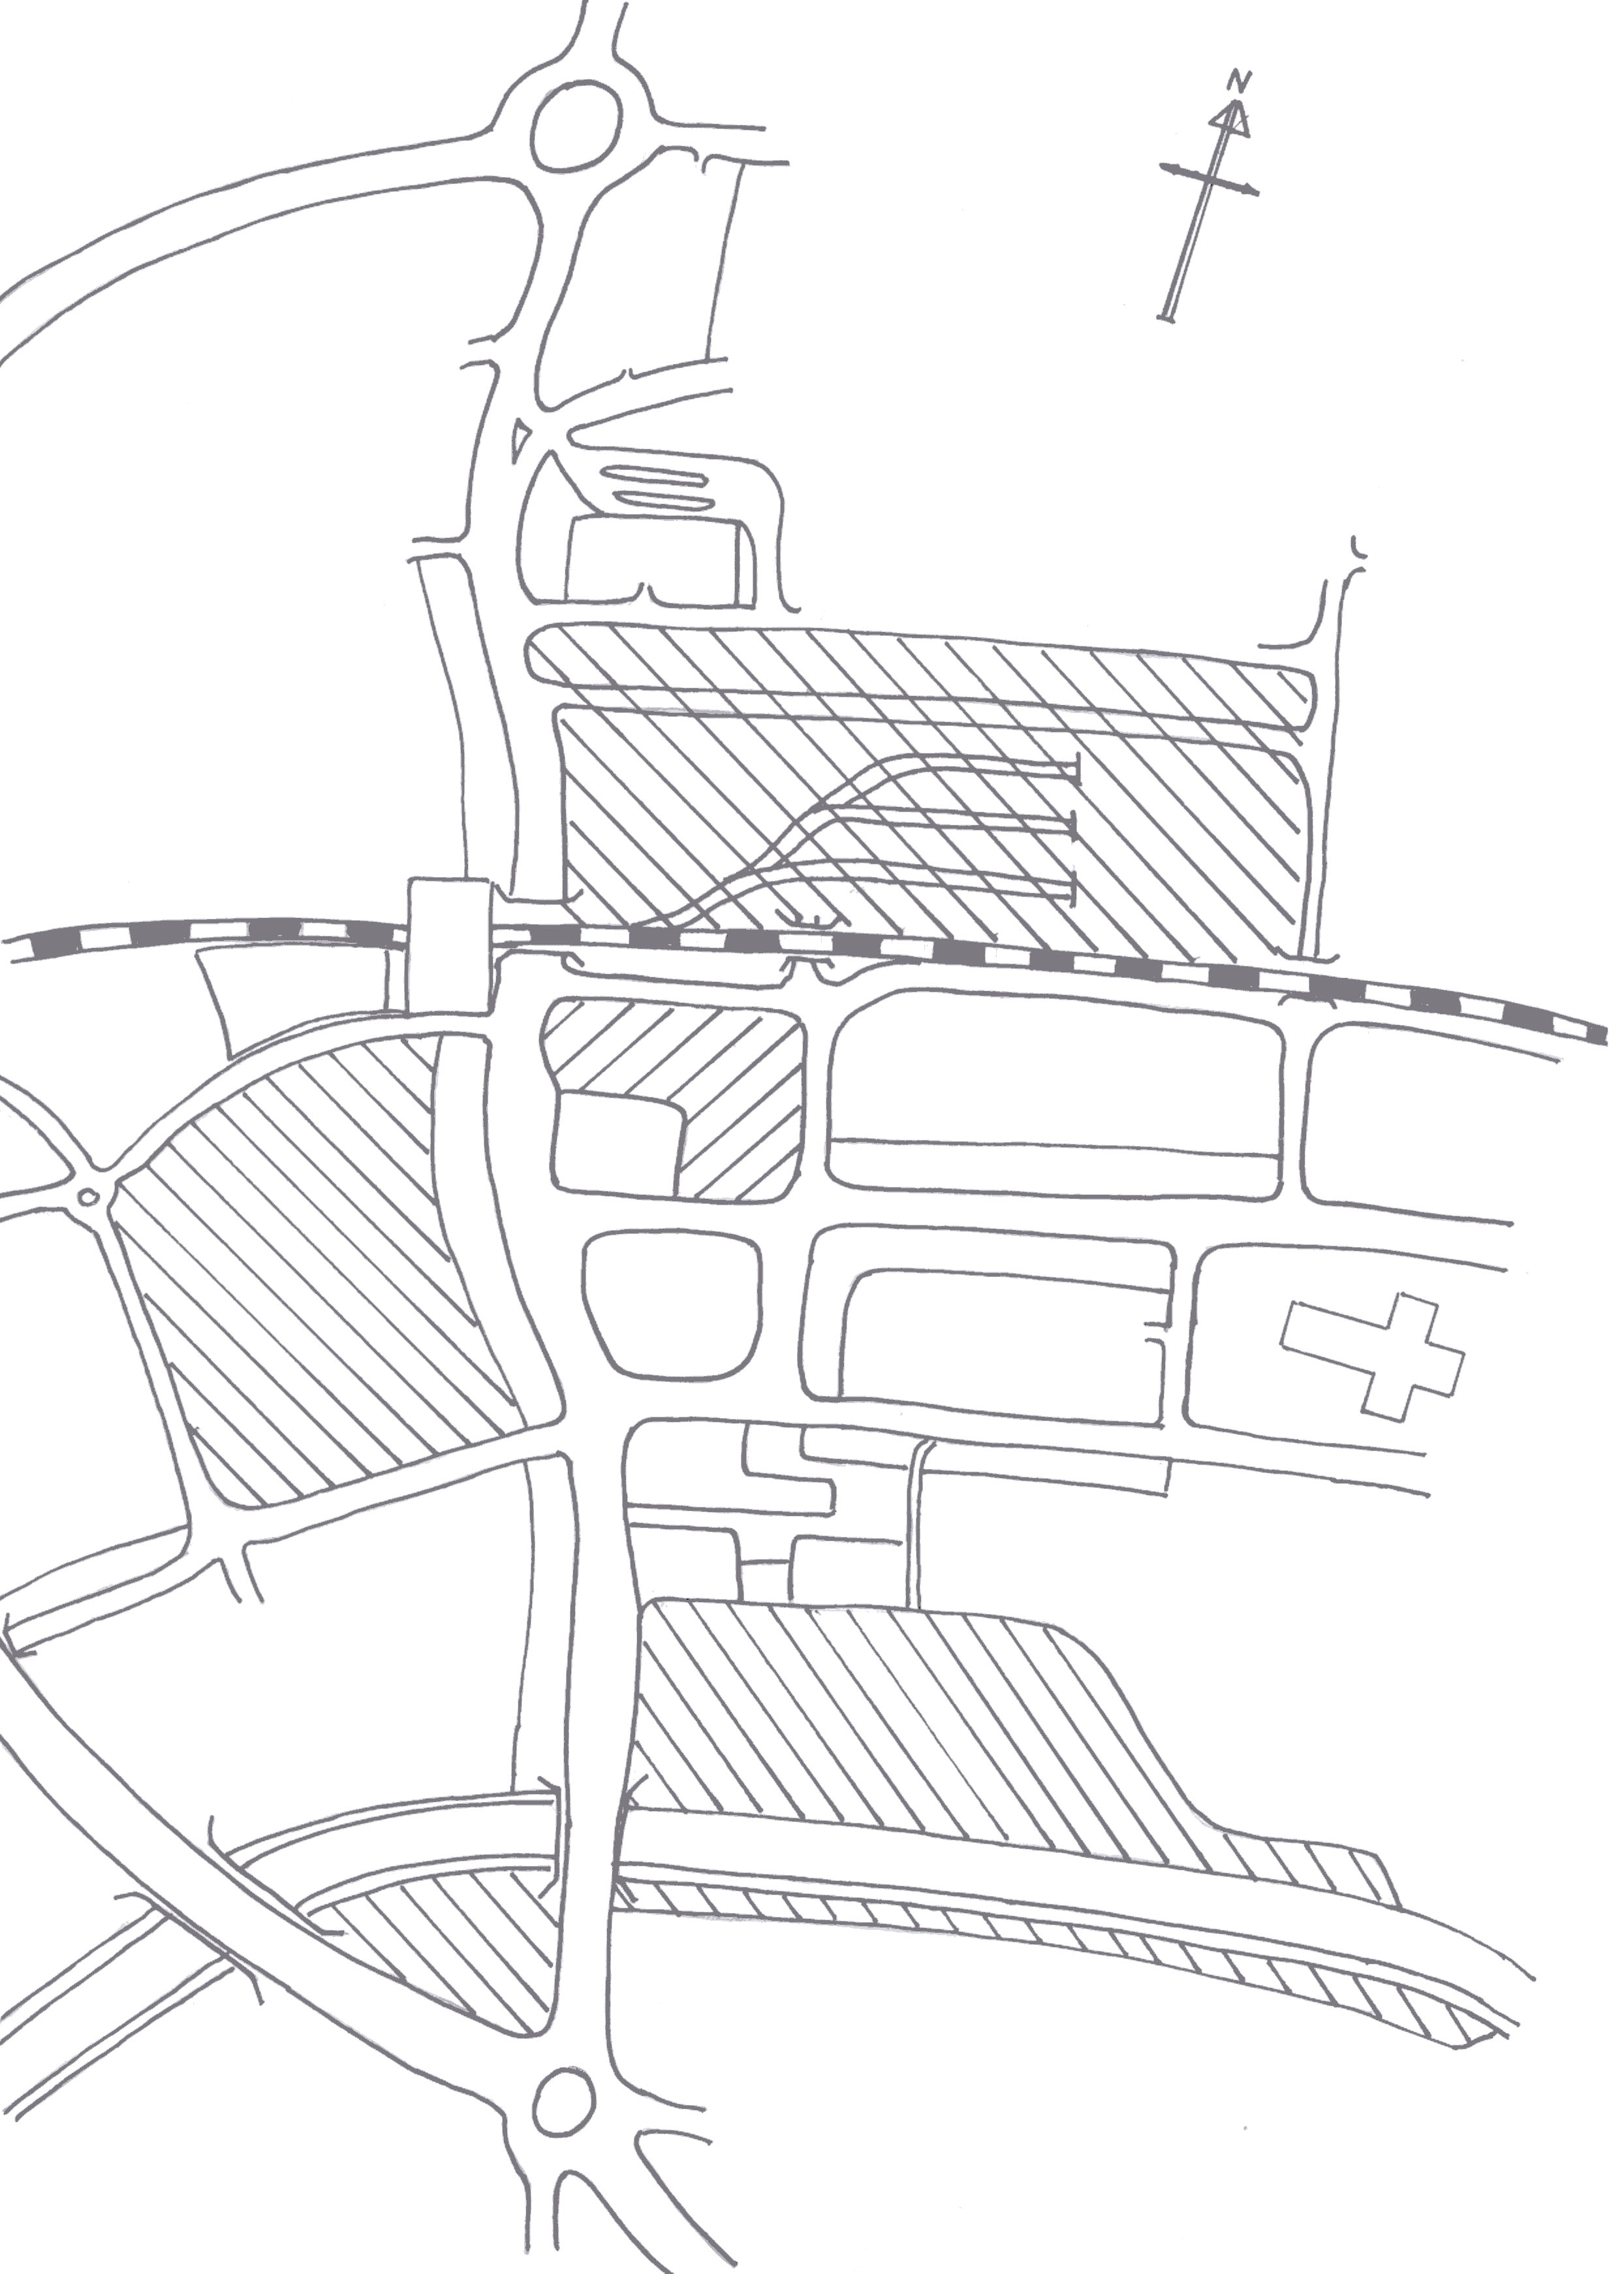

C – Crown Printers PLC