Design

Task – Re-development of Harchester

TASK: As a Managing Director of your company I have commissioned a survey by an independent consultant to help start the process. This has been funded impart by the council who are keen to get things moving.

Stage 1 Read the survey and produce a summary/checklist of the report, highlighting the key features and including some initial suggestions for ways forward. This can be presented either in a report form or PowerPoint presentation.

Stage 2 Select one zone and produce a mind map on that zone to include existing features which need to be considered as well as ideas for that zone development.

Stage 3 Research existing schemes and try to pick out what and how they have approached the problem.

Stage 4 Produce a range of rough ideas for the development of the zone in 2D and/or 3D, use notes to explain your thinking and ideas. Use colour to make the sheets interesting.

Harchester is a small country town, which is starting to suffer from competition from a near-by and larger town. This other town has a large number of out of town centres as well as a retail and leisure park. Over the last few years, Harchester’s shopping centre has started to empty, of both shops and shoppers.

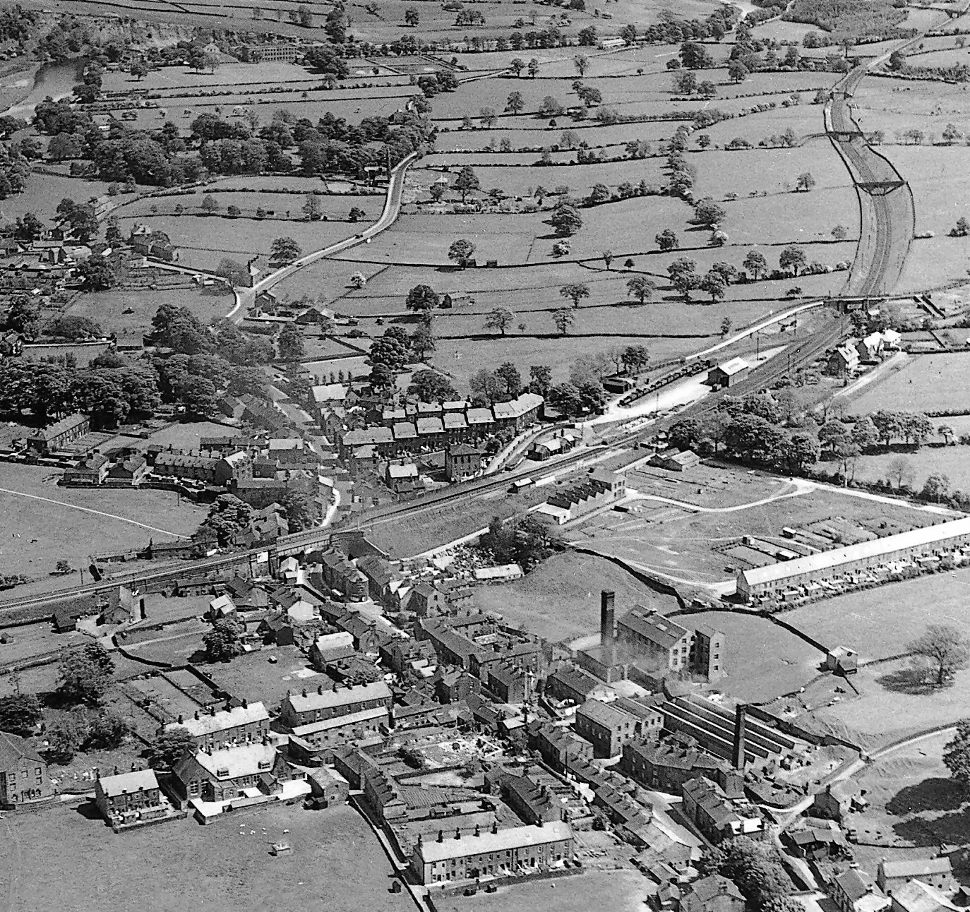

Your design company has been approached to tackle the major re-development for Harchester. The project has a wide brief because the town council realise the seriousness of their situation. They are looking to you to come up with not only an environmental and building programme, but also an approach to tackle the issue of the town’s image and the need to attract people back.

Money is not a concern as they are have received a range of massive cash grants from the County Council as well as from the government, who support the need for the town’s regeneration. The local rail company, Network Rail and British Waterways are also prepared to invest in the town by supporting the development of the areas they own, if the over-all scheme is appropriate.

