Town Centres – Bus Company – New Corporate Identity

THE SITUATION
The first phase of money has now come through from the government and the Bus Company has decided to begin its development. The starting point is the image of the company, at present it is called the Harchester Bus Company and they feel this is out of date and presents the wrong image.

They are in negotiations for selling their present site and have gained planning permission for a new depot and headquarters, which will be located at the edge of town. They are also hoping for funding for the Park & Ride scheme to come through in the near future and suitable sites have already been identified. They are also in the process of purchasing new buses and mini buses to replace the existing fleet.

AIM
To design a new image for the bus company, focusing upon the developing a new name and logo/trademark. It is the intention to use this for all their stationary, as well as for the corporate signage on the new building.

They also want it to be incorporated into the livery on the new buses, so further projecting a very strong brand equity. The image they want is one of quality of service, convenience and comfort.

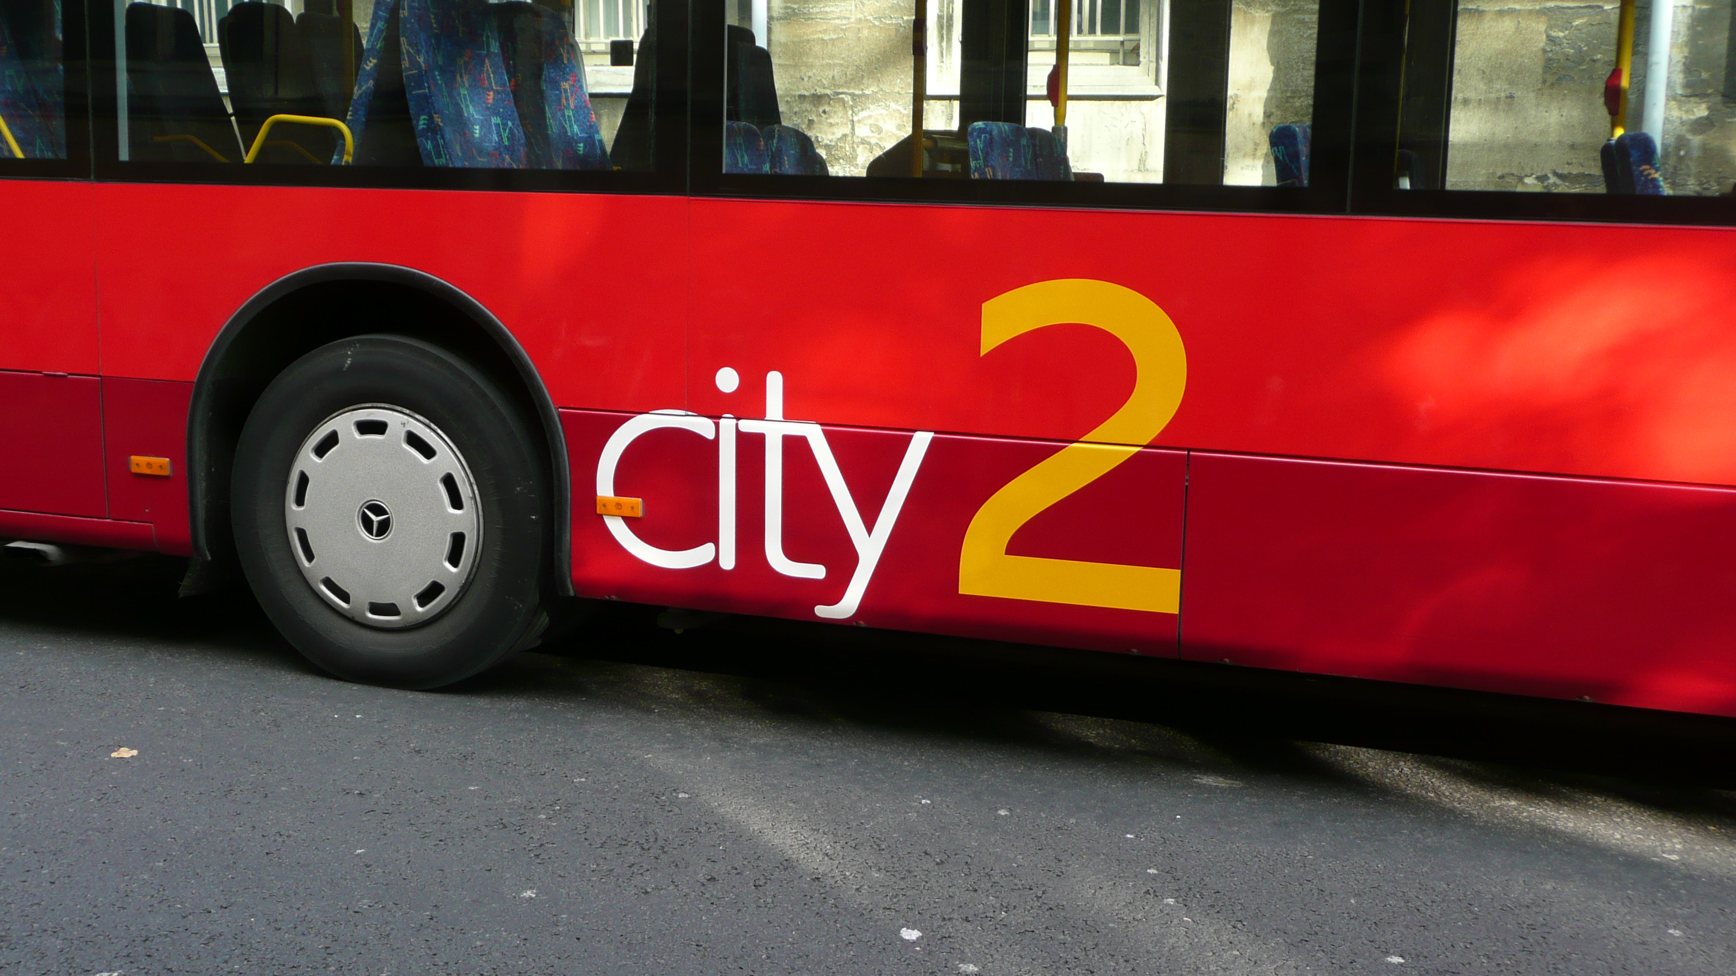

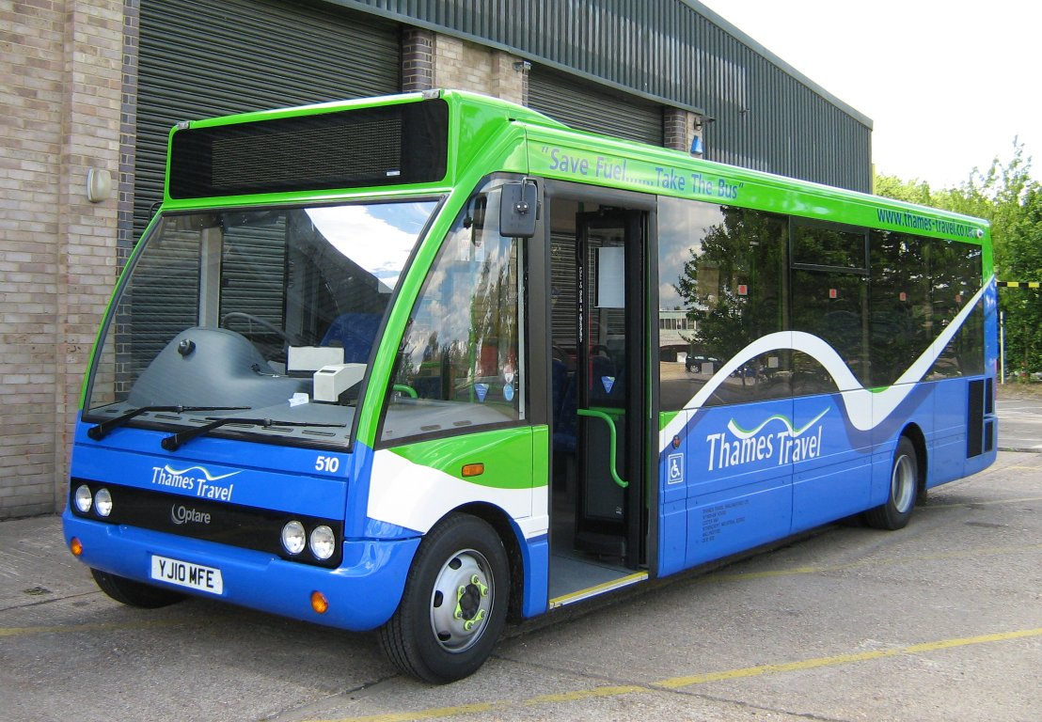

For the design task complete the sections list below, on the pages shown.
- Design Specification (4 marks)
- Research (10 Marks )
- Initial Ideas (12 marks)
- Development (12 marks)
- Final design (8 marks)
- Product Testing (4 marks)

