Design & Technology
2019
Study Skills for DT
Contents

Introduction 3
Organisation 4
Courses 5
Independent study 6
Motivation 7
Time Management 8
Learning Styles 10
Different Methods of Learning 13
Note Taking 19
Reading Skills 21
Revision strategies and Exam preparation 22
Dealing with Stress 26

Appendix
Q & A 27
Checklist for organisation 29
Independent learner Assessment 30
Revision/Exam checklist 31
Support Details 32

Sixth Form

DT Study Guide

Introduction

Most of you will find that working in the Sixth Form is a completely new approach to study than you are used to. It is important to start with a positive frame of mind and keep motivated throughout your courses.
It might not be easy, but the Sixth Form will provide you with opportunities to build self-confidence and develop new skills, preparing you for the outside world. You will be given work that is more demanding than you have previously been used to and you will be put into unfamiliar situations, which may be challenging, but remember, we are here to support you.
The most important new skill you will learn is how to become an independent learner. You will need to get used to spending time studying in the evenings and at weekends and organizing and manging your own time. Not all of this studying will be directed by your teachers, so you will need to initiate your own study, for example reading around the subject and making regular revision notes.

Organisation
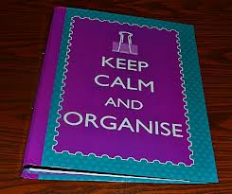
Preparation
Make sure you have all the essential equipment that you need before the start of term: files, dividers, pens, highlighters, note pad, diary, plastic wallets, memory stick, dictionary/thesaurus etc.
Find out what exam board runs the course you are studying and download a copy of the syllabus.
Buy study guides.
Do background reading.
Complete checklist in Appendix!
During the week
Keep your planner/diary up to date. Write down when work is set with a due date. Also, keep track of work completed and work outstanding.
From the start of your course make sure that you have separate files for each subject with file dividers for each topic.
Make sure all notes are dated and add them to your file straight away
Add all handouts to your file as you get them; keep some plastic wallets in your file in case they are not hole-punched.
Keep to a regular work rota. Do small chunks of study often rather than leaving large amounts of work to do at the last minute. Work that is done late is often rushed and not good quality.
Get a dictionary. Always proof read your work checking spelling and grammar before you hand work in.
Make use of all resources available to you – teachers; Internet; text books; newspapers; libraries; television; radio; VLE
Prioritise what you need to do; don’t put off harder pieces of work.
Make sure you work in an environment where you won’t be distracted or disturbed.
It is advised that most students need to do 4-5 hours of extension study per subject each week.
Make sure you understand what you need to do. Ask for advice if you are not sure!

Courses


‘A’ level and BTEC courses will be taught in relatively smaller groups than at GCSE.
Lessons may be slightly less formal but will still require high standards of behaviour.
Your subject teachers will give you support and guidance and you should be able to talk to them about any concerns or difficulties you may have about the course before it becomes a problem.
If you are taking a BTEC subject, your teachers are no longer able to give structured written feedback. They will only be able to give verbal feedback, so it is essential that you listen to the teacher carefully and make notes in order for you to complete work to the standard required.
If your work doesn’t meet the required standard after marking, you may be allowed a second attempt to meet Pass, Merit or Distinction. However, this is only if you met deadlines and can make improvements independently.
Therefore, it is essential that you proof read your work and check for spelling and grammar mistakes before handing in completed work.
If you have any questions, speak to your teachers.




Independent Study and Independence
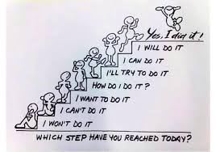

Studying in the Sixth Form will involve a great deal of time spent in independent study. You will need to take responsibility for your own learning.
This will involve you working at home in the evenings and at weekends. You must learn to manage your time effectively as it is now required that you are in 540 hours of study per year.
It is a good idea to make a homework timetable at the start of the year so that you make sure you are spending enough time on your work as well as giving yourself time to spend on other activities.
You may start a part time job, but make sure that it doesn’t get in the way of your academic studies.
You will have time on your timetables when you are not in lessons; these are not free periods but time when you should be studying independently. It is recommended that you spend 4-5 hours of independent study for each subject per week.
Some study periods may be supervised study in the Sixth Form Study Centre, where a member of staff is available if you require help.
You will need to plan your study time carefully to make sure you meet deadlines and don’t fall behind with your work.
You will also need to organise where you go to study.
Where to Study?

Silent Study: Quite Zone in Sixth Form Study Centre
Group Study: Sixth Form Study Centre, Library

Motivation


Your attitude to learning is EXTREMELY important.
Positive feelings will help brain cells connect which improves learning.
Your brain learns valuable information faster if it is important.
So, think - what will I get out of learning?
It might be going to college or university; good job prospects; an apprenticeship; improving your future; a good career; improving your confidence or proving to yourself that you can do it!
Give yourself short term and long-term goals.
Make sure you give yourself rewards for short term goals. Do something you enjoy, such as going to the cinema; going out for a meal; spending time with friends etc.
A short-term goal could be completing a piece of coursework so that you are free for the weekend.
Build up your confidence by setting short achievable targets which will help create a positive attitude to learning.
A long-term goal may be working towards a place at university or college.
Regularly remind yourself of your long term and short-term goals.
People who lose motivation usually lack confidence, direction and focus but this can be overcome by using the above simple techniques.

Think of the bigger picture!


Time Management
Workload and meeting deadlines – Planning


- Many students feel that time management is the hardest aspect of study skills. The best way of managing it, is good planning.

- Successful people see Time management as one of the most important reasons for their success.

- If you fail to prepare, you will prepare to fail!

Yearly Planning
It can be helpful to fill in a year planner at the beginning of the academic year. This can be attached to your wall where it is a visual reminder of the year ahead. It will help you plan for long term deadlines.
You can add holidays, school trips, modular and end of year exams, unit deadlines, careers conventions, university open days and any other event that will affect private study.
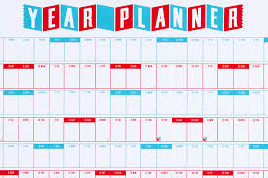

Weekly Planning
You will have a timetable of your lessons for the week ahead.
Plan at least one hour of study time for each hour of lesson time for each subject.
Try to create regular study times for each day. This will help make studying a habit.
Make sure you plan what you are going to do in your study periods for the week.
It is very easy to waste time if you haven’t planned what you need to do. Work out where you are going to go; look up which rooms will be free at the times required.
At the beginning of the week decide what research; reading round the subject; writing up of notes; essay planning; drawing, etc. you need to do.
Try to balance your activities so that you get free time for friends, family, sports, television etc.
Keep your schedule flexible, so that when unexpected events occur swap your times around rather than getting rid of study hours.
Make a weekly ‘To Do’ list on Sunday for the week ahead.
Keep your weekly plan realistic!
Reward yourself for using study time effectively!
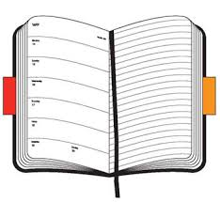
Daily Planning
Make sure you record homework and coursework deadlines as soon as you get given them in your diary.
You can then prioritise which pieces of work need to be done first.
Make a daily ‘To Do’ list each night or first thing each morning.
Keep the list with you.
Prioritise the most important things on your list, marking them with an Asterisk
Break down large tasks into smaller achievable chunks
Cross out things you have completed to help you visualise what is left to do and give yourself a sense of achievement.
If you use these methods of time planning, along with your own determination, you will become organised in all areas of your life and will be up to date with all your work at school.
Learning Styles
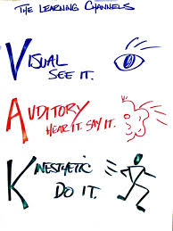

To become a good independent learner, you need to know what your preferred learning style is.
Most of you mayalready know your preferred learning style, but if you are not sure try as many different methods of learning as you can, until you find something that works for you.
Our senses are extremely important in the way we learn. Most people are visual learners, auditory learners or kinaesthetic learners; however, some use more than one style of learning.
Each time you work in a different way you will make stronger brain cell connections and stronger memory links, therefore using a multi-sensory approach will make learning easier and quicker.
Visual learners
Learn by looking, watching, drawing, reading and writing
When trying to remember, they imagine the image of page or screen

Auditory Learners
Learn by talking, discussing and listening
When trying to remember, they will imagine who said it and the discussion

Kinaesthetic learners
Learn by doing, moving, exploring
When trying to remember, they will imagine where they were when they learnt it

Tips for Visual learners


Make your notes colourful; highlighter pens are good for this.
Make mind maps, spider diagrams, posters, diagrams, flow diagrams, charts, word walls, flash cards
Use DVD’s, visual programmes for revision, YouTube
Display key words and information around your room to improve memory.
Convert text/key information into a picture or diagram
Look, cover and learn

Tips for Auditory learners


Do any activities which involve reading and listening or speaking
Group discussion and debate
Describe out loud what you are doing as you do it
Make rhymes, songs, raps from key ideas
Use Mnemonics and Acronyms, for example AFOREST, SURF CREST, PEEL
Discuss plans, ideas and answers with a partner
Teach someone else what you have learnt
Use podcasts, record yourself speaking and listen to them while you are on the bus or in the car etc.
Use rhythm to learn key information such as spelling
Link music to learning, the same piece of music for the same subject each time
Create your own quizzes
Listen and learn

Tips for Kinaesthetic learners


Use models, take them apart and build them back up.
Use paper based activities, such as drawing things out or card sorts.
Write notes or key words on post it notes or cards and organise, sequence, plan, classify or turn into mind maps.
Turn card sorts into games.
Use movement while listening, reading or talking out loud.
Physically repeat/practise key things that you want to remember.
Point and follow with your finger.
Do and learn.



Different Methods of Learning
You need to look after your brain properly, if you want to be an effective learner. It needs the right amount of nourishment, food and water, as well as plenty of rest and exercise. Try to get eight hours sleep per night, exercise regularly and always eat breakfast!
Your brain is split into two hemispheres, the left and the right.
The left side deals with order, sequences, logic, numbers, words, lists, analysis and language and prefers a step by step approach.
Whereas the right-side deals with: imagination, colour, shape, 3d pattern, rhythm, meaning/experience, awareness and prefers to look at the whole picture.
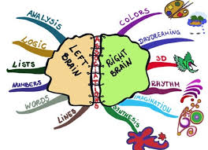
Many people have a preference for one side but if you use both sides of your brain it will increase your ability to learn and remember.
At school, you probably use the left side of your brain more than the right.
You use lined paper; you make lists; the main item in your notes will be words and you try to be logical in what you do. This means you are only using half of your brain’s potential!
Your brain thinks and remembers in colours and pictures, so it is important to use these when you are learning and revising!
How to improve your memory
See it → visualise or draw it
Personalise it → make it unique to you
Exaggerate → learn or practice in an unusual way
Connect it → compare to something else
Share it → teach it to someone else

Mind Maps
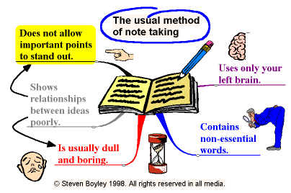

Mind Maps are a brilliant method of learning; they allow you to use both sides of your brain so that you unleash your brain’s amazing potential!
Mind maps are made up of words, colours, lines and pictures which help you to remember. They are
- an excellent way to plan and come up with new ideas

- an alternative way to make notes that is not boring!

- a quick and effective way of revising

- a brilliant way to help plan and structure an essay

- an important tool for learning

Advantages:
- You only need to write down what is important

- You can use pictures and diagrams

- You can easily show how things link together

- They help you to think about how different concepts are linked

- All the information you need is on one page

- The visual pattern will help your brain to remember the important points
How
All you need are coloured pens, paper and your brain.
They are very easy to construct.
Start with one central picture.
Draw the main branches of the mind map expanding the key focus into a set of sub points.
Draw sub branches as your ideas move on by association.
Use imagination to develop the map using picture and word associations.
Keep adding branches until you run out of ideas.
Use What, Where, When, Why, Who and How to help you
The aim is to reduce a page of text by approx. 90% so that you learn the essential details.

Mnemonics and Acronyms
Mnemonics are words or abbreviations that help you to remember.
Acronyms are words made up, using the first letters of other words.
They are especially useful when remembering order is important.
E.g. Richard of York gave battle in vain – colours of the rainbow
AFOREST FLAP
Anecdote Form
Fact Layout
Opinion Audience
Rhetorical Question Purpose
Exaggeration
Statistics
Triples

These are easy to remember and you will probably remember the information forever!

Flow Charts
These are diagrams showing steps in a process.
Each step leads on to the next one, and gives alternatives to show there can be different outcomes, depending on the choices you make. E.g. Steps you need to follow in a computer program or a Science experiment.

There are three main symbols used:
Elongated circles, which show the start or end of the process
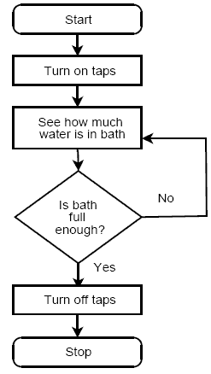
Rectangles, which show instructions or actions
Diamonds, which show decisions to be made
Within the symbols write down what the symbol represents
The symbols are connected to each other by arrows which show the flow of the process.

Wall Posters/ Word Walls
You can make these with key points and words to help you learn the language used for your ‘A’ Levels and BTEC courses.
Put them up in your bedroom and around the house.
You will subconsciously look at these throughout the day.
You could use different rooms for different subjects.

Revision cards
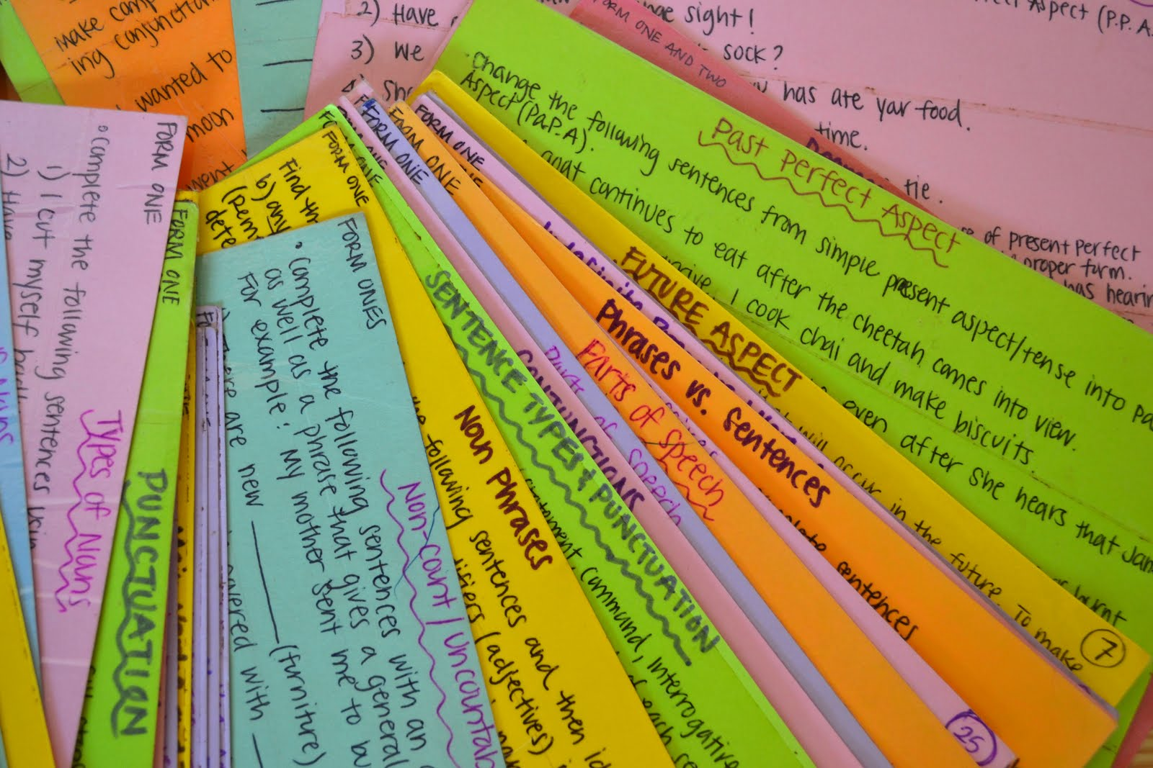
These can be really helpful in remembering information.
You could make a different coloured set for each subject.
You could put a question on one side and the answer on the other or….
List key facts, words, points, dates, formulas, key exam words etc.
For example: analyse, compare, contrast, describe, justify, evaluate.....know what they mean and what the examiner is looking for.
Cards can be linked together by a key ring or treasury tags.
Carry them around with you, going over them in any spare time.

Revision Cards are an effective way to increase your performance and an effective use of your free time.

Past Papers
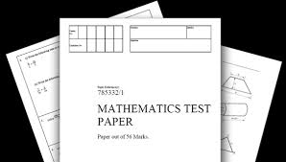
These are an extremely important resource.
Go to the DT website, or the exam board’s site, and download the past papers, mark schemes and examiner’s reports.
You need to practise plenty of past papers. Identify areas where you are not so confident, practise techniques and sort out problems before you try the next paper.
Try and test yourself against the clock, this will help you with timing as well as the style of question.
Remember to check the examiner’s report afterwards for comments and guidance, the more recent ones have tips and exam advice as well.

The more past papers you complete and understand the better prepared you will be.

Teaching someone else
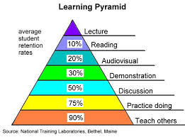
One of the most effective ways methods of learning is to teach someone else.
As you explain the information to others, it helps you to process and understand it.

Teach a friend or family member.

Music

Music can help get your brainwaves into the right rhythm for learning.
Listening to classical music can help some people relax and focus.
Background music can help you make associations with particular pieces of information.
Always use the same piece of music for the same subject you are revising.

However, research has shown that many people find that studying in silence is the most effective way to revise.

YouTube, Pod casts and audio recordings
Record key points onto your iPod /phone or download relevant podcasts.
Listen to these while travelling by car, on the bus or walking home etc. Remember, YouTube may have good examples of the industrial processes you need to understand.

Note taking
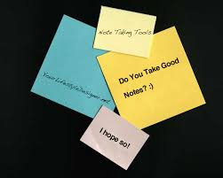

Importance
Helps you think about the key ideas and issues
Focuses your attention
Helps you understand text
Helps you memorise things that you need to learn
How
Make your notes visual and colourful, using pictures, symbols and diagrams.
Mind Maps are a great way of doing this.
Highlight and underline key ideas to focus your attention but don’t highlight too much!
Make notes clear and neat.
Use abbreviations to make notes more concise.
Present notes in point form or under sub headings.
Don’t write everything that the teacher has said or written; add your own comments to help you understand.
Make notes detailed enough for Sixth Form study, but not too detailed and lengthy.
When taking notes from the internet make sure the source is reliable.
Be careful not to copy and paste information straight from the web site, you must be able to take it in and understand what you are writing.
If you do copy information from the internet you must acknowledge the site in your references, footnote, bibliography or appendix.
It is plagiarism if you fail to do this and you may be disqualified from modules or subjects!
Keep your notes in subject folders in date order.
Finally read over your notes as soon as you can to underline key points and add in any extra notes so that they make sense when you come back to them for revision.
Style
Make sure the notes you make are in a style that suits you!
Either:
Mind maps showing connections between ideas
Spider diagrams
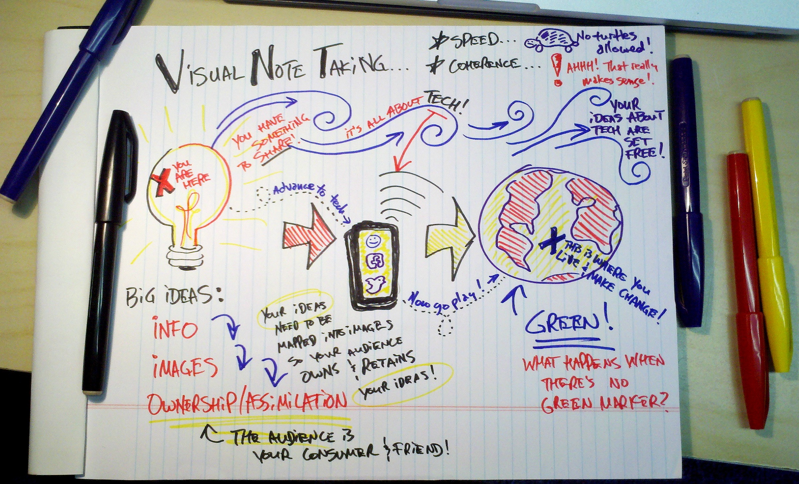
Sub headings and key points
Bullet points
Visual – story board, poster
File cards

Try to be as visual as you can!

Benefits
Don’t forget, visual methods of note taking will allow you to use both sides of your brain making it easier for you to remember them!
A good set of notes is invaluable, they give you evidence of the work you have done and are an effective form of revision.

Reading skills


Reading is essential at Sixth Form level.
You will need to come to terms with the amount of reading you will be required to do as well as understanding and trying to remember what you have read. You will be introduced to new words, so make sure you take time to use a dictionary or text book glossary to help you understand new language and technical terms.
Different approaches to reading:
Skimming
This is looking quickly through the textto get a rough idea of what it contains. Look at titles, sub headings, diagrams, illustrations, summaries and footnotes.
Scanning
This is a quick search for important points or particular information. You need to scan your eyes across the page until you find a specific word or phrase and then read that section carefully to see if it is relevant. Ignore everything except for the information you are looking for.
Detailed reading to understand
This involves careful reading and studying of the passage or article you have found, by skimming and scanning. You need to read carefully in order to understand and take in the main facts and ideas.
You may need to read it more than once and take notes to summarise, if you want to study something thoroughly.
Ask yourself questions about what you have just read to check your understanding.
To study effectively you need to be able to vary your reading style and switch from one method to another.
Revision strategies and Exam Preparation
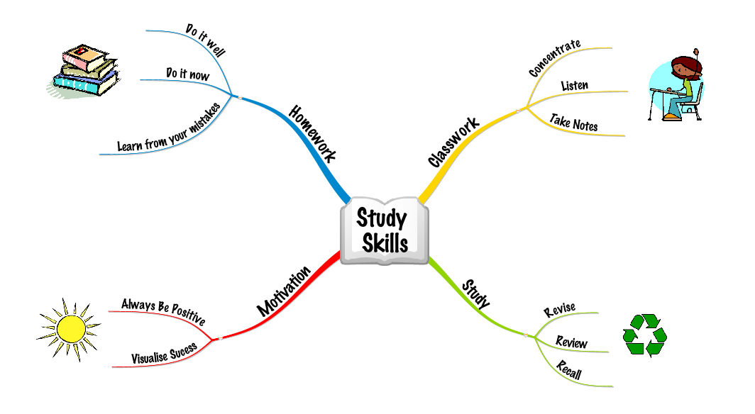

Your brain works best in 35-40 minutes bursts, followed by a 5 – 10minute break of a completely different activity. Reward yourself with something you enjoy!
Many people find that revising early in the morning works really well, try starting at 9.00am or earlier!
Plan your work in bursts, have only a few key points in each burst.
People learn best at the beginning and end of revision sessions so make sure you revise in lots of short bursts.
Always review your learning. Recall after learning will be improved if you leave10 minutes for it to sink in and then go over it again.
80% of what you put into your long-term memory is lost after 24 hours unless you review it again.
The trick to successful revision is the 6 x rule
- Test yourself straight away

- Test yourself an hour later

- Test yourself the next day

- Test yourself after 3 days

- Test yourself after 3 weeks

- Each time, learn again the bits you have forgotten
Making it memorable:

Listening to a lecture 5%
Reading 10%
Audio-visual 20%
Demonstration 30%
Discussion 50%
Practice by doing 75%
Teach/immediate use 90%

Start revision early!
Use as many of these different methods of revision as you can:
- Revision cards
- Mind maps
- Highlighting
- Past papers
- Word walls
- Posters
- Teaching someone else
- Revision websites
- Post it notes around the house
- Revision buddies
- Listening to podcasts or self made recordings of key points etc.
- Recite things out loud
- Revise to music – same subject, same piece of music

For details see Methods of Learning - P13-18.

Where to study
Study in a well-lit place which is quiet and where you won’t be disturbed.
OR
Study with friends. This can sometimes be helpful as you can share ideas and help each other with areas you find difficult. This can also be helpful with motivation.

Make a Revision Timetable
Traffic Light your topics;
- No idea - red,
- Ok – amber,
- Confident – green
Identify what you don’t know and revise those areas

- Make a list of subjects you need to revise
- Work out which subjects need the most revision
- Concentrate on the areas you are weakest on
- Break down revision subjects into smaller parts
- Include break times
- Don’t leave the hardest subjects till the end of the day; get them out of the way first.
- Cross of revision periods when they are completed
- Review your progress at the end of the week and change plans accordingly.
- Use colour to show different subjects, or order of importance.
Don’t spend too long revising one subject.
Revise in bursts of 30 – 40 minutes
Your brain is most receptive in alpha rhythm. It is in this rhythm for 15 to 20 minutes before you fall asleep at night and after you wake up in the morning; Use these times for a final look at your revision notes.

Exam Technique

- Remember timing

- Read questions carefully

- Keep calm

- Plan your answers

- Check your work

Remember to get enough sleep and food before the exam!
Do not leave revision to the last minute!

What?
Traffic Light your topics; No idea - red, Ok – amber, Confident – green
Identify what you don’t know and revise those areas
Down load past papers, mark schemes and the syllabus from exam board websites
Use on line resources
Mind map key concepts for each topic
Use the 6 ‘W’ questions Who, What, Why, Where, When, How

Why?
Research shows that if you link your learning to your goals you will go on to achieve better results.
How?
Effective revision goes hand in hand with your preferred learning style
Visual learners
Learn by looking, watching, drawing, reading and writing
When trying to remember, they imagine the image of page or screen

Auditory Learners
Learn by talking, discussing and listening
When trying to remember, they will imagine who said it and the discussion

Kinaesthetic learners
Learn by doing, moving, exploring
When trying to remember, they will imagine where they were when they learnt it

Who?
Involve as many people as possible,
Study groups work well
Teach someone else and then let them teach you
Where?
A distinct study area with your time table clearly displayed
Ideally somewhere with natural light and good ventilation
No distractions
Revision resources, organised notes and study guides nearby
When?
Have your revision time table on the wall
Work in 30 minute chunks with 5 minute breaks
Give yourself rewards
Avoid distraction
Effective Revision Skills
Dealing with Stress
Make sure you eat five helpings of fruit and vegetables each day; vitamins are very important!
Exercise for 20-30 minutes at least 3 times per week.
Give yourself time to rest and relax.
Be proactive with dealing with problems; talk to someone about how you feel and what your worries are.
Believe in yourself
Don’t try to be perfect
Don’t keep things bottled up
Keep things in perspective
Talk to friends, family and teachers (anyone you can trust)
Get regular amounts of sleep
See mistakes as positives
Exam stress; It is ok to feel some nerves, if you forget something or go blank, close your eyes and breathe deeply and tell yourself you can do it!
Finally, if things get too much, talk to someone, never leave it, remember, we are here to help you and school should be fun!!!


Appendix

Questions& Answers

- Q. How much time should I spend on independent study for each subject per week?

- Approx 4-5 hours per subject, usually the same amount of hours as lesson time per week.

- Q. Where can I go to study?

- Silent study: Quiet Zone in the Sixth Form Study Centre, Library, free rooms.
Group study: Sixth Form Study Centre
Computer access: In Sixth Form Study Centre and you can book a computer/note book.

- Q. What is the ideal length of time that I should split my study/revision into?

- 30 -45 minute sessions of active study. Give yourself a break/reward before you start your next study session.

- Q. How can I keep my study notes organised?

A. In Folders/Files with dividers, date each piece of work, keep notes in order, hole-punch handouts/ sheets and add to your files as soon as you get them.

- Q. How can I use my study time effectively?

- Out of your study periods in the week, you should use 7 or 8 of them for active studying – get into this habit early on, don’t be tempted to sit around and chat.
Plan where you are going to go to study.
Look ahead each week and plan what you need to do, to get work completed on time.
Create a clear timetable of when to study at home.

- Q. What do I need to do before the beginning a course?

- Buy resources e.g. files, pads of paper, file dividers, plastic wallets, pens, etc.
Do relevant background reading and buy study guides.

- Q. How can I make sure that I keep up to date with work?

- Plan time effectively by using yearly, weekly and daily planning. Use study periods effectively.

- Q. What should I do if I am really struggling with a subject or particular piece of work?

- Speak to your subject teacher, Mr Cove or Ms. Morbey
Don’t leave it and pretend everything is alright, the situation will get worse and you will drop further behind. ASK FOR HELP!

- Q. How can I improve my ability to study/learn?

- Make good effective notes to help recall; read actively; work as a group to share ideas, help with understanding and motivation to complete assignments; reread notes after taking them and test yourself on your understanding each night; use strategies e.g. Mnemonics; visual revision techniques and note taking.

Q. Where can I find information to help me to complete work?

A. Internet (remember to save the website as a reference to your source of information), DT website, DT VLE, Library books, study guides.

11.
Q. What do I need to do if I am not going to be in a lesson?

- If it is a planned absence you will need to inform the school before you go.
If the absence is unplanned you must contact the school by phone or email on the day
Whatever the reason for your absence the school must be informed.
12.
Q. What is the best way to prepare for exams?

A. Make a revision timetable. Revise effectively, in short bursts with breaks in between. Always review what you have learnt, to help you remember. Use revision strategies that work best for you and work in a quiet place where you won’t be disturbed.

Organisation Checklist

Item | Tick
Folders

Dividers

Highlighters

Note pads

Pens, pencils, etc.

Memory stick

Plastic wallets

Planner

Study Guides

Year Planner

Background reading

Quiet place to work

Deadlines for work written in to diary

Check DT websites and access (Passwords)

Successful Independent Learner Assessment

I regularly do: | Tick
Organise my work/folders/notes

Have at least one folder for each subject

Plan ahead

Spend 4-5 hours private study per subject each week

Make a timetable of when and where I do my private study

Ask for help when needed

Take effective notes

Proof read my work

Use a variety of ways to learn and revise

Organise and use my time effectively

Meet deadlines

Use different sources of information to complete tasks

See mistakes as part of the learning process

Set myself high but achievable goals

Don’t give up when work is challenging

Revision/Exam Checklist

Item | Tick
Exam time table

Revision timetable ready

Past papers printed

Mark schemes printed

Examiner’s reports printed

Past papers completed

Past papers marked

Using a variety of methods to revise

Quiet place to work

