Packaging
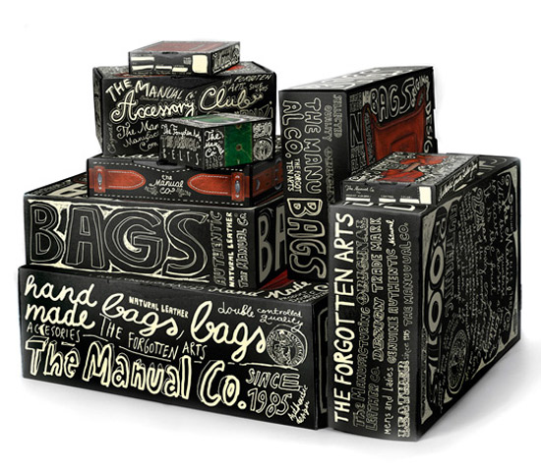

Select a product of your choice and design its packaging.
It must be imaginative, creative and exciting.

Assessment Criteria
Presentation Brief and Selection of Product
Research
Net development/Thumb Nails of possible designs
Final Design
Outcome Completion & Quality of Final Prototype
Concept Quality of Solution

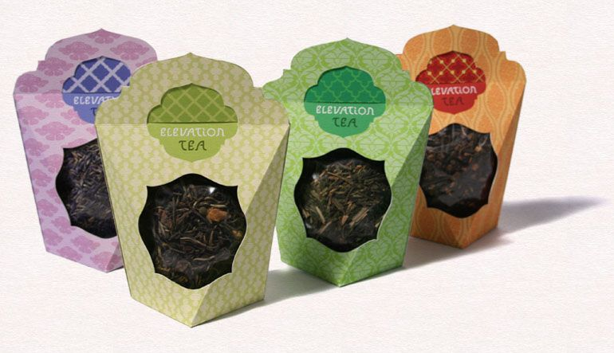

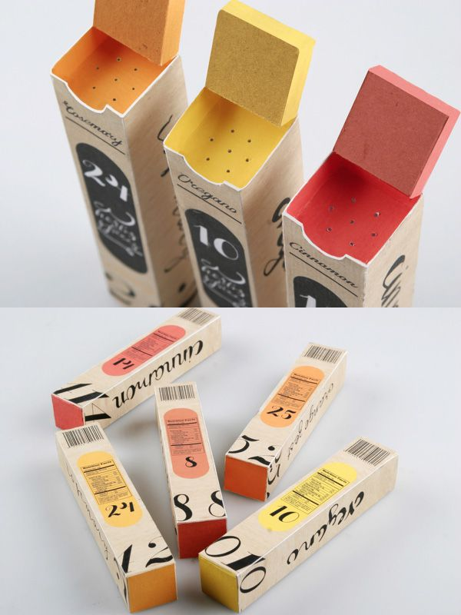

Hand-in Wednesday 4th July 2018 – 3.00pm

