*Set at the turn of the century, the story centres on a young* [*solicitor*](http://en.wikipedia.org/wiki/Solicitor)*, Arthur Kipps, who is summoned to Crythin Gifford, a small market town on the east coast of the* [*United Kingdom*](http://en.wikipedia.org/wiki/United_Kingdom) *to attend to the funeral and to deal with the estate of Mrs. Alice Drablow, an elderly and reclusive widow who lived alone in the desolate and secluded Eel Marsh House which surveys the windswept reaches of the salt marshes beyond Nine Lives Causeway. However, all is not what it seems and the town is haunted by a dark secret from its past in a ghost story which is tragic, vengeful and chilling.*



Now, all around and above and way beyond there seemed to be sky, sky and only a thin strip of land. I saw this part of the world as those great landscape painters had seen Holland, or the country around Norwich. Today there were no clouds at all, but I could well imagine how magnificently the huge, brooding area of sky would look with grey, scudding rain and storm clouds lowering over the estuary, how it would be here in the floods of February time when the marshes turned to iron-grey and the sky seeped down into them, and in the high winds of March, when the light rippled, shadow chasing shadow across the ploughed fields.

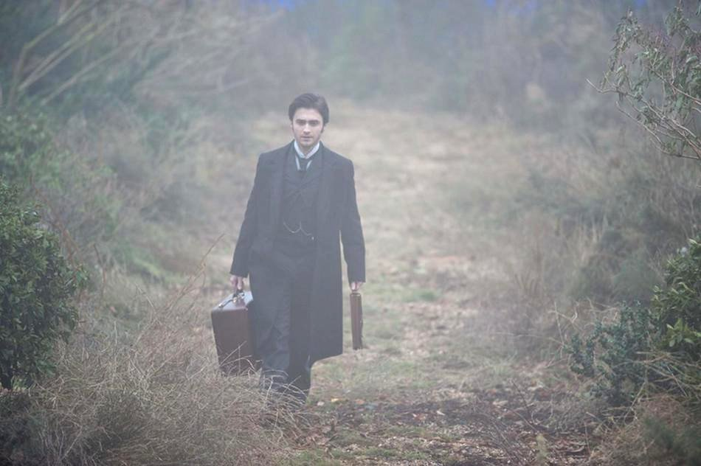

Today, all was bright and clear, and there was a thin sun overall, though the light was pale now, the sky having lost the bright blue of the morning, to become almost silver. As we drove briskly across the absolutely flat countryside, I saw scarcely a tree, but the hedgerows were dark and twiggy and low, and the earth that had been ploughed was at first a rich mole-brown, in straight furrows. But, gradu­ally, soil gave way to rough grass and I began to see dykes and ditches filled with water, and then we were approaching the marshes themselves. They lay silent, still and shining under the November sky, and they seemed to stretch in every direction, as far as I could see, and to merge without a break into the waters of the estuary, and the line of the horizon.

My head reeled at the sheer and startling beauty, the wide, bare openness of it. The sense of space, the vastness of the sky above and on either side made my heart race. I would have travelled a thousand miles to see this. I had never imagined such a place.

The only sounds I could hear above the trotting of the pony's hooves, the rumble of the wheels and the creak of the cart, were sudden, harsh, weird cries from birds near and far. We had travelled perhaps three miles, and passed no farm or cottage, no kind of dwelling house at all, all was emptiness. Then, the hedgerows petered out, and we seemed to be driving towards the very edge of the world. Ahead, the water gleamed like metal and I began to make out a track, rather like the line left by the wake of a boat, that ran across it.

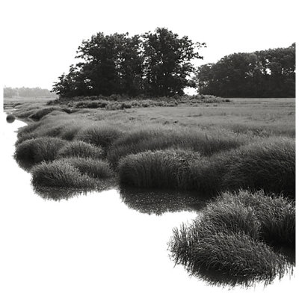

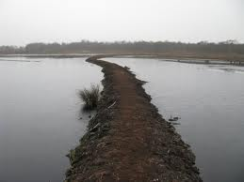

As we drew nearer, I saw that the water was lying only shallowly over the rippling sand on either side of us, and that the line was in fact a narrow track leading directly ahead, as if into the estuary itself. As we slipped onto it, I realized that this must be the Nine Lives Causeway - this and nothing more - and saw how, when the tide came in, it would quickly be quite submerged and untraceable.

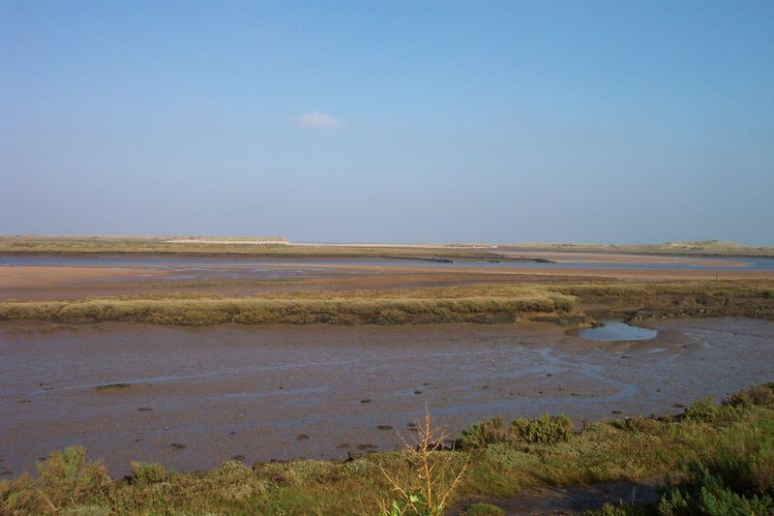

At first the pony and then the trap met the sandy path, the smart noise we had been making ceased, and we went on almost in silence save for a hissing, silky sort of sound. Here and there were clumps of reeds, bleached bone-pale, and now and again the faintest of winds caused them to rattle dryly. The sun at our backs reflected in the water all around so that everything shone and glistened like the surface of a mirror, and the sky had taken on a faint pinkish tinge at the edges, and this in turn became reflected in the marsh and the water.



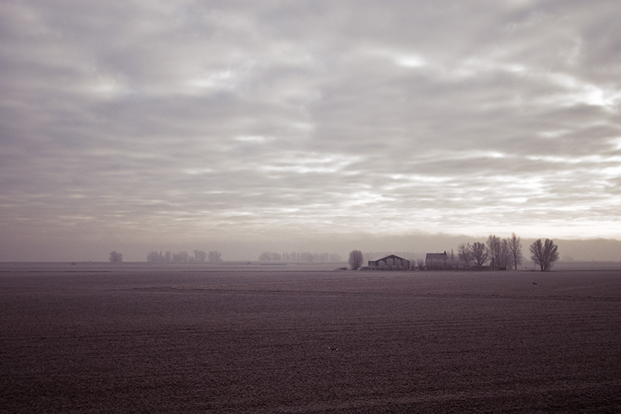

This little island extended in a southerly direction across an area of scrub and field towards what looked like the fragmentary ruins of some old church or chapel.

There was a rough scraping, as the cart came onto the stones, and then pulled up.

We had arrived at Eel Marsh House.

Then, as it was so bright that it hurt my eyes to go on staring at it, I looked up ahead and saw, as if rising out of the water itself, a tall, gaunt house of grey stone with a slate roof, that now gleamed steelily in the light. It stood like some lighthouse or beacon or martello tower, facing the whole, wide expanse of marsh and estuary, the most astonishingly situated house I had ever seen or could ever conceivably have imagined, isolated, uncompro­mising but also, I thought, handsome. As we neared it, I saw the land on which it stood was raised up a little, surrounding it on every side for perhaps three or four hundred yards, of plain, salt-bleached grass, and then gravel.