Rapid Prototyping

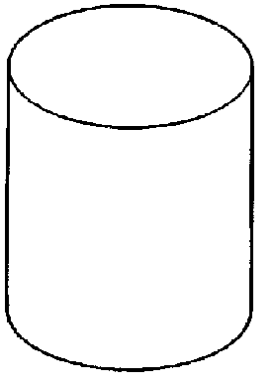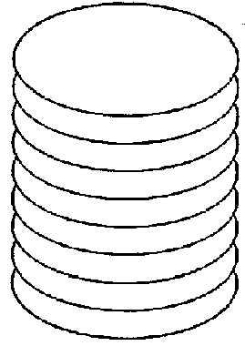This is a process used to produce a prototype model in a very short time, in days rather than weeks. Traditionally, drawings would be produced and sent to a toolmaker to make up. This would take a number of weeks and on its return it would be tested. Modifications may need to be made so the process would be repeated. With Rapid Prototyping this can be done in a couple of days directly from CAD software. Through an additional programme, the object would be sliced up into 2D layers or slices.

This data is then transferred to one of the rapid prototyping machines/processes; each 2D layer would be then be reproduced to create the complex model.

Laser

These layers can be:
Layer Epoxy resin
Sand
Paper

The three main processes are:
1. Stereolithography SLA
2. Laminated Object Manufacture LOM
3. Selected laser Sintering SLS

On the next few pages are diagrams explaining each machine.

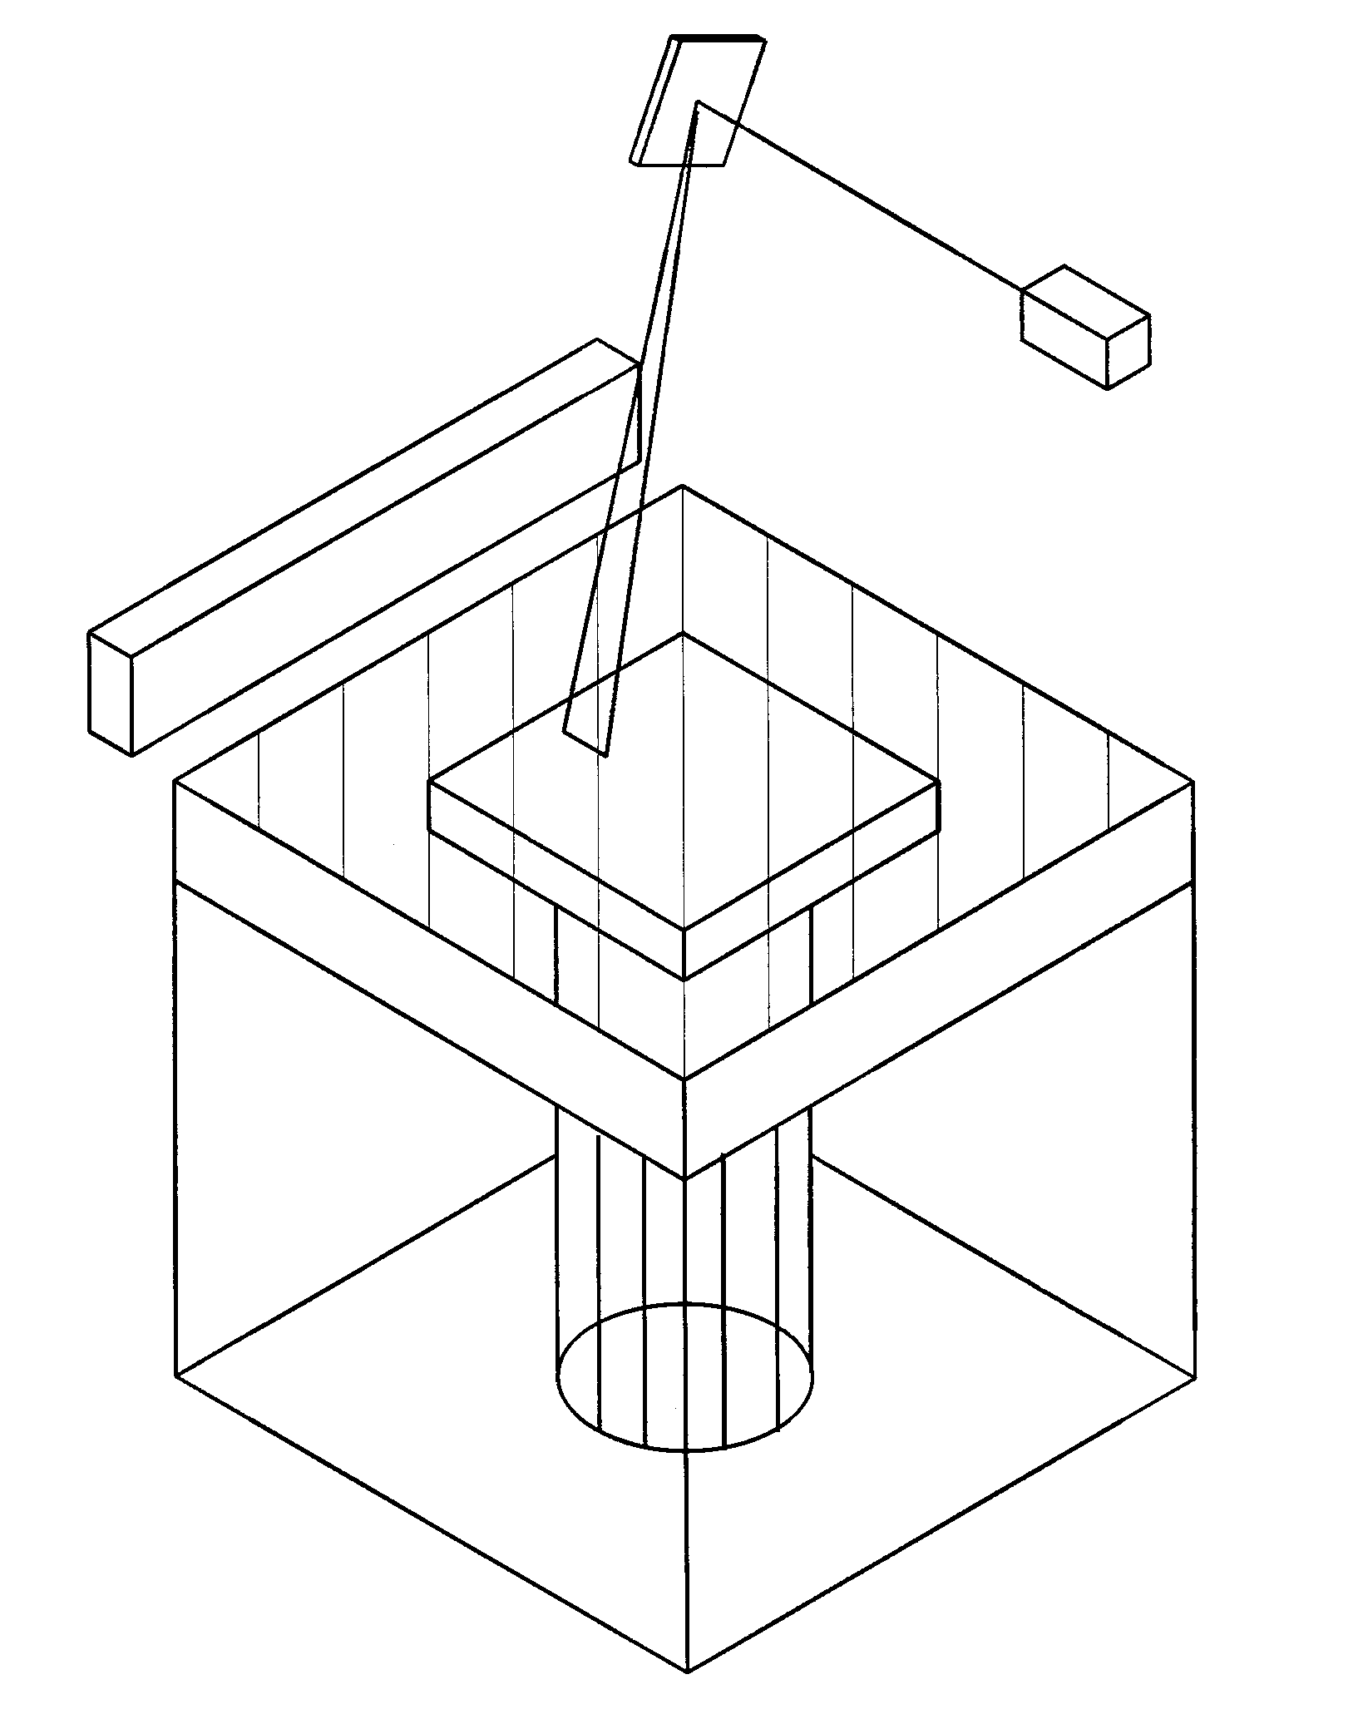Stereolithography - SLA
Re-coating Reservoir sweeps over after each layer
Laser & Optics
Platform – Z axis
Goes down after each layer

Fine Detail

Slightly Transparent

Brittle

Laminated Object Manufacture - LOM

Material: Paper, Acrylic, Polystyrene

Layer thickness: 0.1- 0.25 mm

Build Dimensions: Up to 800mm x 500mm x 450mm

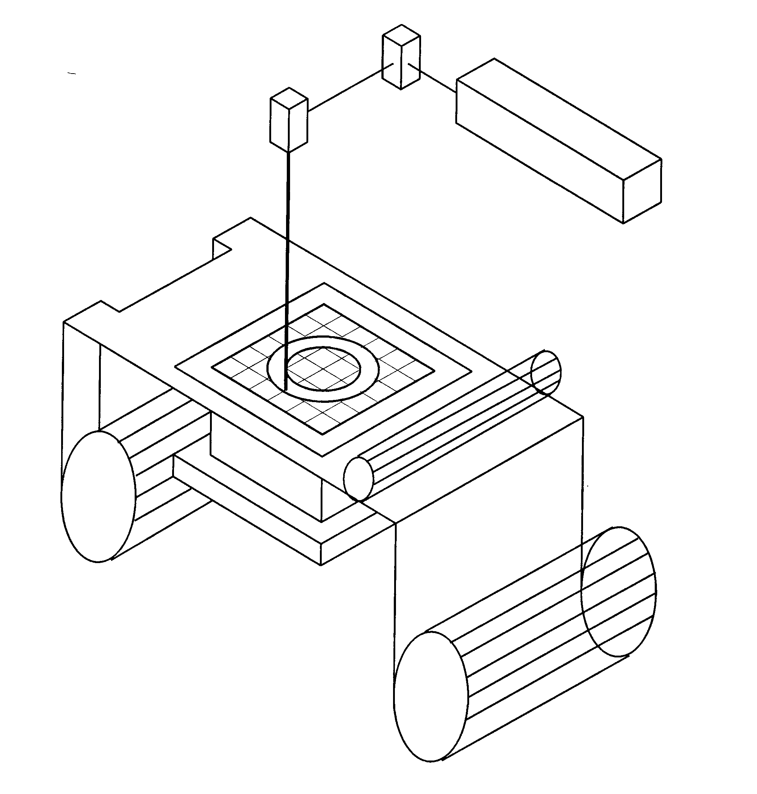
Laminating Roller
X-Y positioning device
Laser & Optics

Platform – Z axis Goes down after each layer
Take-up Roll
Material Supply Roll

Fine Detail

Slightly Transparent

Brittle

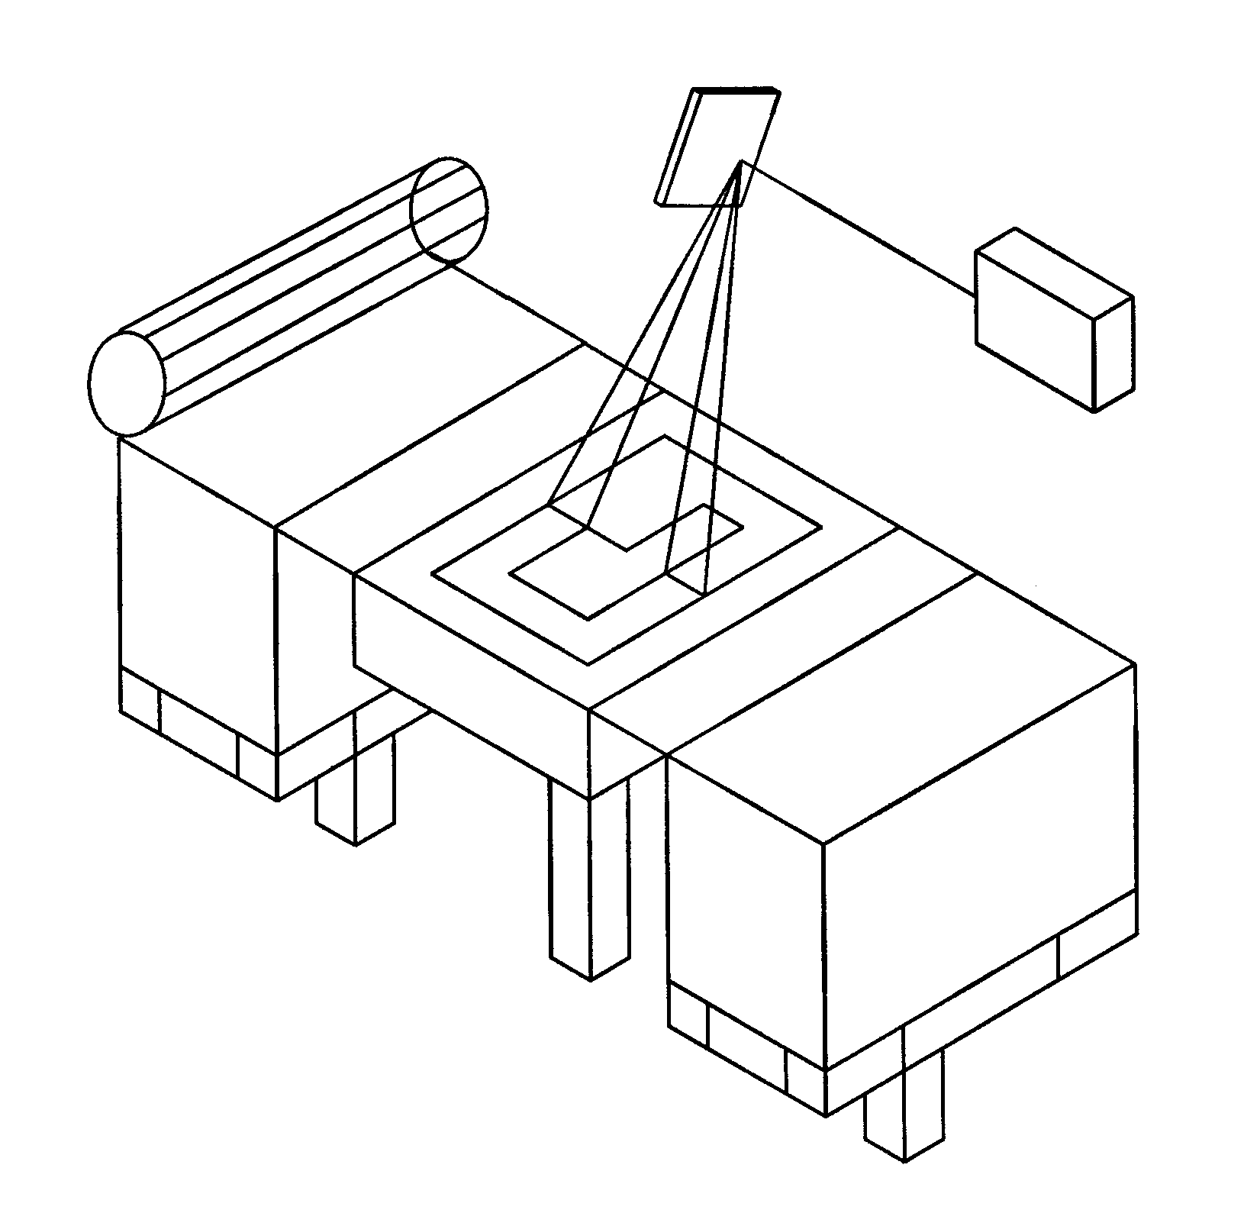Selective Laser Sintering - SLS
Scan Direction
Powder Feed Roller
Laser & Optics

Material: Powder Process, Sand, Nylon, Wax, Polycarbonate

Layer thickness: 0.1- 0.15 mm

Build Dimensions: Up to 750mm x 350mm x 350mm

Build Envelope Piston
Powder Feed Cartridge
Powder Feed Cartridge

Powder textured finish

Can be flexible

Can be used for moulds in casting

Material: Powder Process, Sand, Nylon, Polycarbonate

Layer thickness: 0.1- 0.25 mm

Build Dimensions: Up to 800mm x 500mm x 4500mm
Platform – Z-axis Goes down after each layer
Take-up Roll
Material Supply Roll

