Packaging Nets (Developments)

http://www.imperialbox.net/custom-boxes-styles

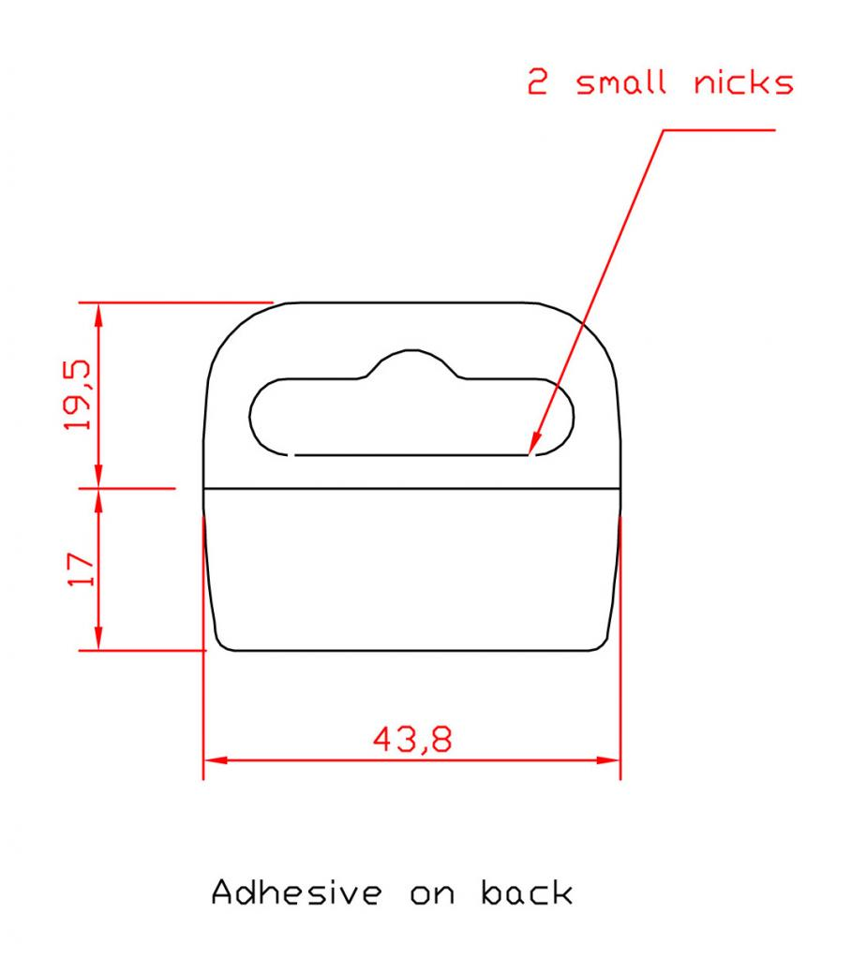

Euro slot hanging tab

