Rapid Prototyping

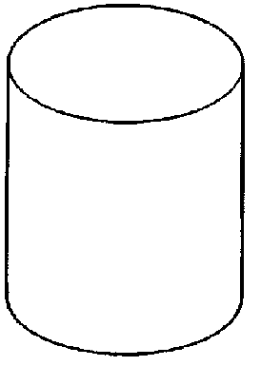This is a process used to produce a prototype model in a very short time, in days, rather than weeks. Traditionally, drawings would be produced and sent to a toolmaker to make up. This would take a number of weeks and on its return it would be tested. Modifications may need to be made so the process would be repeated. With Rapid Prototyping this can be done in a couple of days directly from CAD software, where it is made into a SLA file and then through an additional programme, the object would be sliced up into 2D layers or slices. ProDESKTOP can do this (Look in the “File” drop down menu and then under “Export”
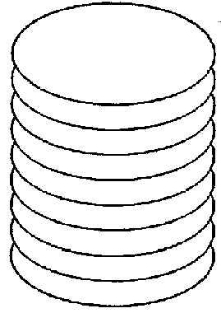
This data is then transferred to one of the rapid prototyping machines/processes; each 2D layer would be then be reproduced to create the complex model.

A laser traces the path in the resin a layer at a time

Layer
0.1-0.25 mm

The three main processes are:

1. Stereolithography SLA Epoxy Resin - for fine objects and detail
2. Laminated Object Manufacture LOM Paper - for large objects
3. Selected laser Sintering SLS Sand - to make a mould for casting

