Measurements of Contents to the Art Box
Requested by Brief
A5 Sketch Book Winsor & Newton A5 Hard Back Wire-o Sketch Book
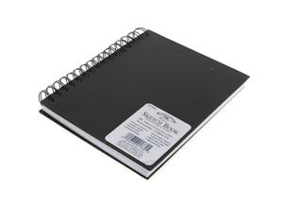
£5.45 212 X 178 X 16 440 g
Heavy weight paper sketch book
Suitable for pencil, pen and ink and light water colour washes
Made using 170gsm acid free paper for longevity

Watercolours Winsor & Newton – Cotman Watercolour Sketcher 14 pieces
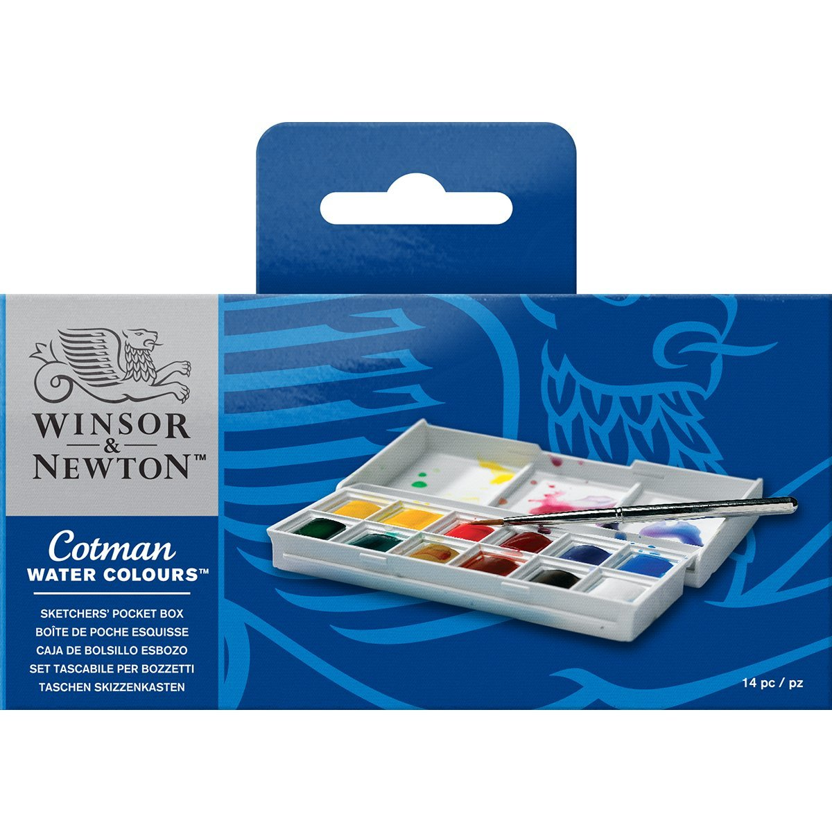
£8.39 130 x 65 x 20 118 g
Pocket-sized plastic box with integral mixing palette
- assorted Cotman Water Colour half pans
- Sceptre pocket brush

Coloured Pencils Derwent Academy Colour Pencils Tin Blendable Colouring Pencils (Set of 12)
£4.99 184 X 12 X 100 100 g
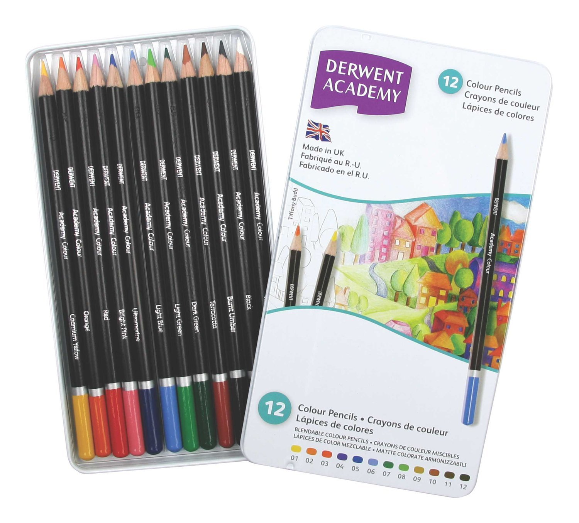
Brushes Royal and Langnickel 5 Piece Starter Set
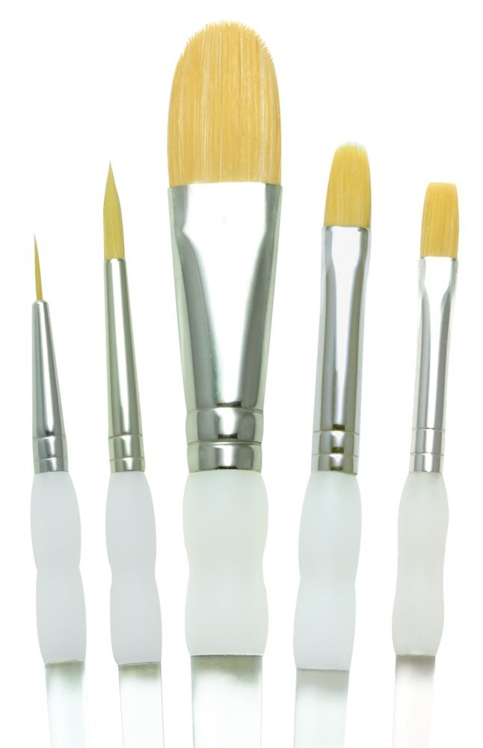
£5.92 269 x 84 x 9

Possible additional items
General Pencil Derwent Academy Sketching Pencils Tin Graphite Pencils 3B-2H (Set of 6)
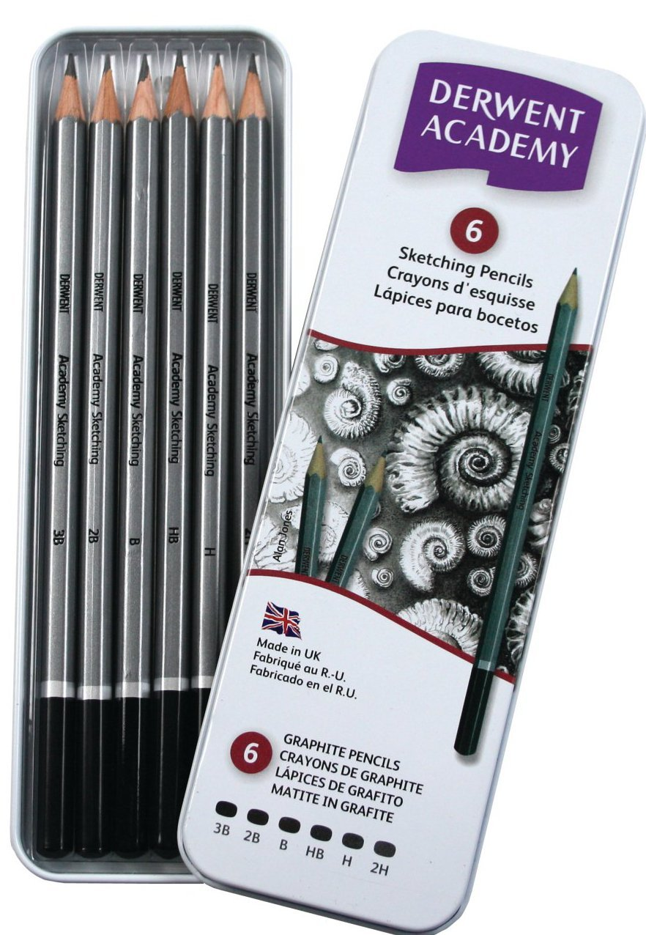
£3.58 185 x 11 x 60 82 g
Sharpener 5 Star Pencil Sharpener Pocket-sized Metal
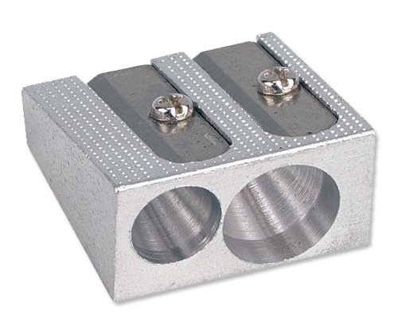
£1.36 23 x 25 x 15 14 g

Eraser Staedtler 526B30 Rasoplast vinyl eraser
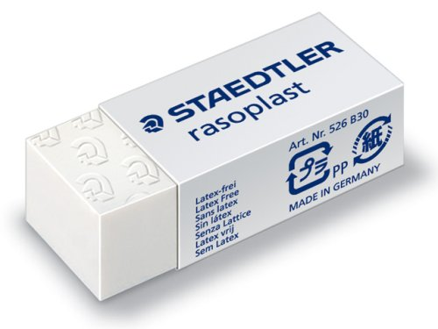
£0.93 43 x 18 x 12 9g

