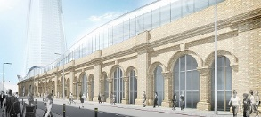

London Bridge Station

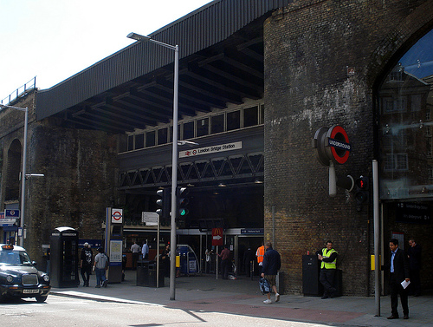

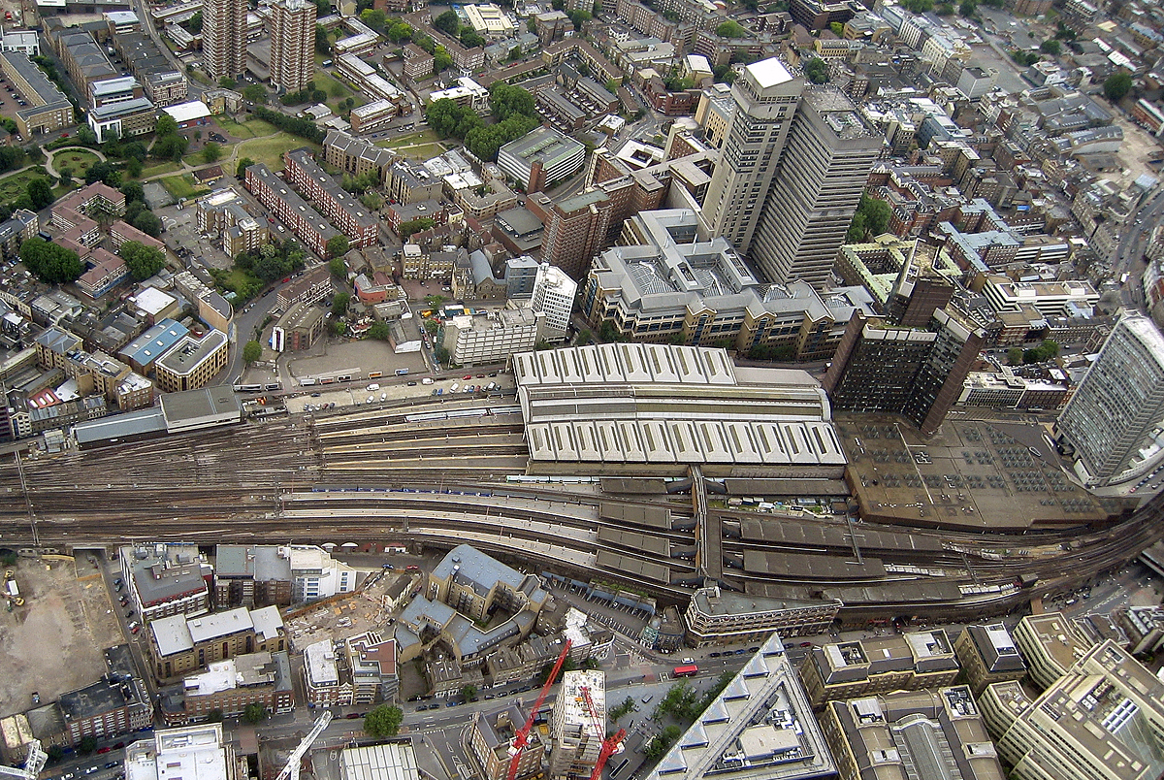

Starts fully 2013

Completed 2018

Cost £400M

The redeveloped London Bridge station will have a new concourse, re-modeled bus station and a public piazza.

117 million people pass through the Station each year, with 54 million starting from London Bridge

London Bridge, is the capitals oldest station, opened 1836 (The year of the Battle of the Alamo), is getting a major redevelopment. The work is being carried out as part of the Shard of Glass construction project.

FUTURE

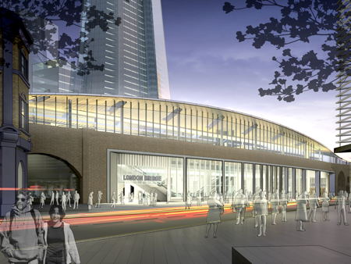

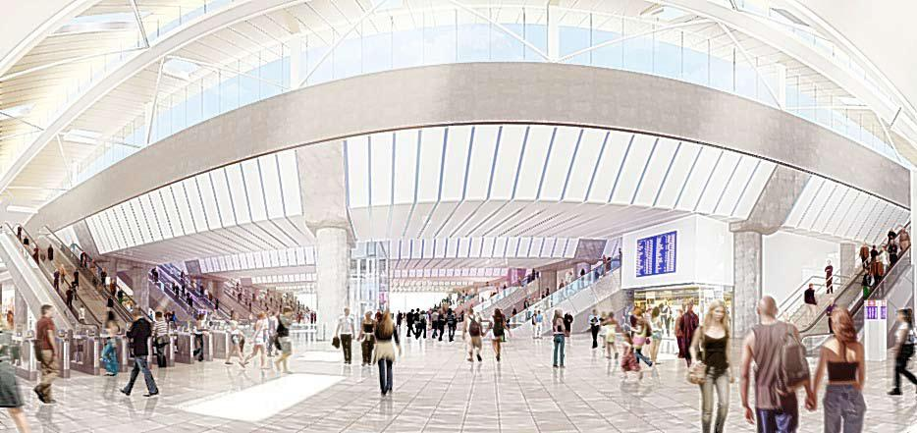

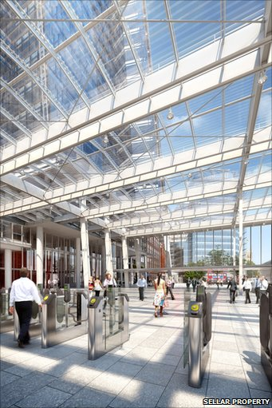

NOW

