Task 4.3 – Seating Area

You have been asked to develop a range of seating for outdoors and could be used around town centres and open public areas. It needs to be flexible enough in its design to enable it to be used in the widest range of outside situation such as the outside areas of cafes and shops. This is to maximise its sales capability.

CLIENT:

Harchester Council

TASK:
To design & make some form of outdoor seating.

OUTCOMES:
- A range of annotated ideas to be presented to the council, in a form of your choice. Portfolio of work to support the project.
- A scale concept model, which will show a range of possibilities.

You must also explain how it can be made, if it was to go into production as well as what materials or range of materials you could use, but remember it must be long lasting, robust and hard wearing. It also needs to be fairly well designed and not old fashioned and you need to ensure it can’t date. You must consider the environment it will be used in and remember the need for easy maintenance. You must consider all these conditions in your design.

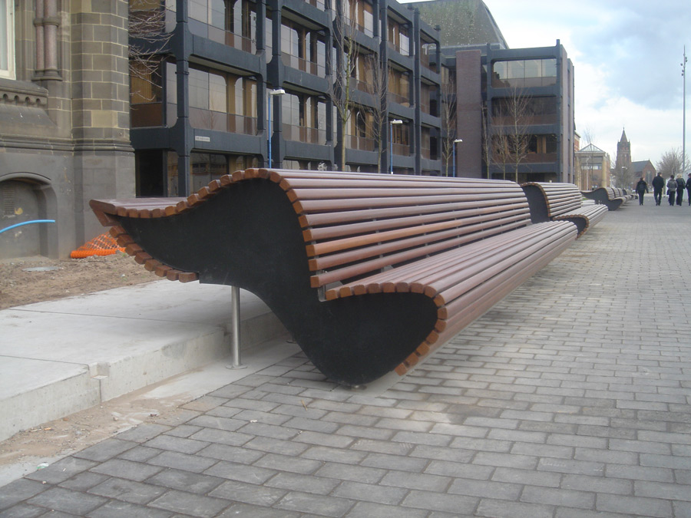
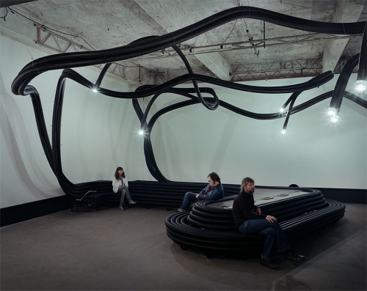
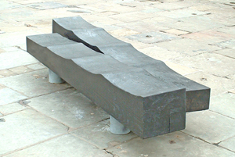

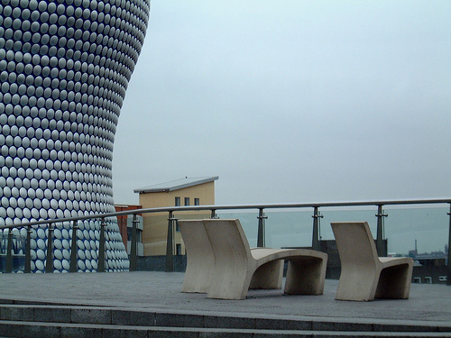
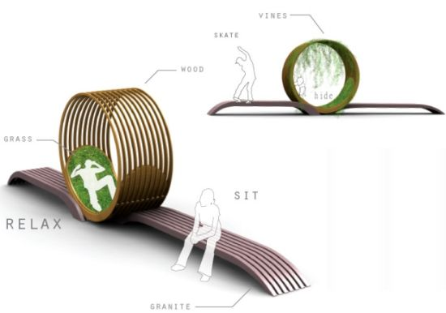

RESOURCES:

- DT Library, DT Magazines, School Website BTEC Section
- 2D Design, Photoshop, Sketchup
- Design Studio, ICT Suite, Workshops

