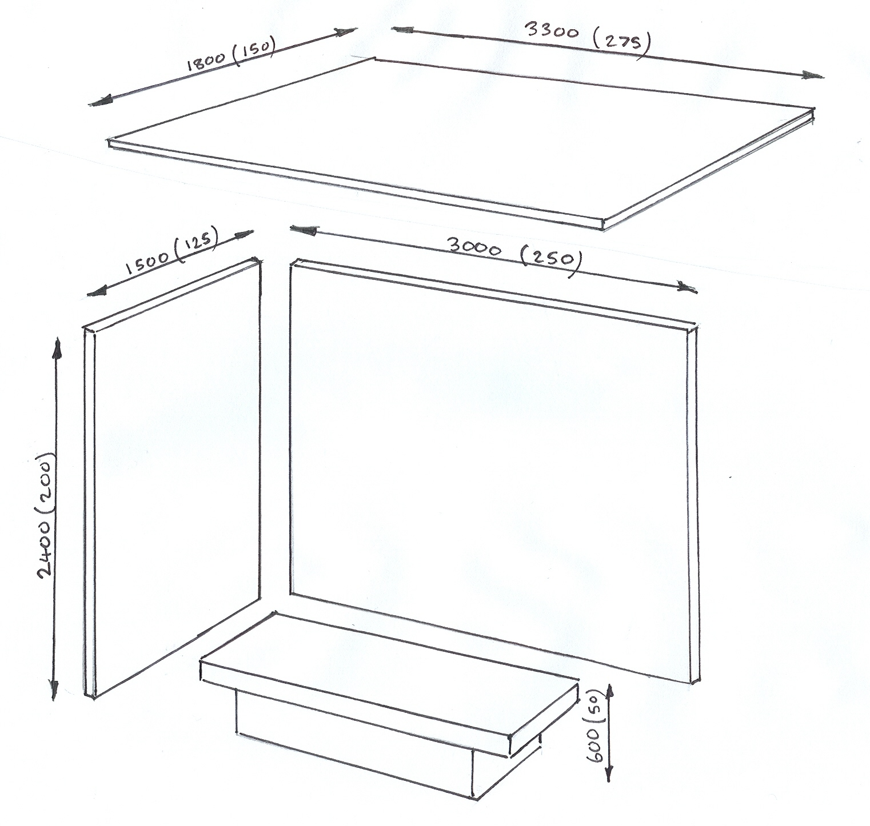

Parts List

1. Side Wall - 200x125x6 MDF

2. Back Wall - 200x250x6 MDF

3. Roof - 150x275x6 MDF

4. Seat - 30x200x12 MDF

- 12x175x32 MDF

Step By Step

1. Get Mr. Jones to cut main pieces out of larger sheet - 2440x1220 sheet of MDF.

2. Mark out holes to be cut, using steel rule and try square.

3. Using 50mm forstner bit, cut hole out on pillar drill.

SAFETY POINT – Ensure work is clamped down on pillar drill using G Gramp.

4. Cut curved edges out using coping saw holding work in woodwork bench vice

5. Clean down with glass paper, ensuring that you glass paper in one direction only

6. Cut straight edge using tenon Saw

7. Use hand file to file flat edge and cut

8. Using a machine vice, drill a 6mm hole into the MDF using pillar drill. This is to fit the 6mm dowel

9. Push the 6mm dowel into hole and decide whether or not it needs gluing.

10. Put together in dry run to make sure all pieces fit.

11. Glue together using woodworkers PVA glue and hold together using masking tape as best as possible.

12. Wipe off as much surplus glue as possible with a damp cloth.

13. Fix metal rods onto roof using Epoxy resin adhesive and masking tape to hold them into position.

14. When dry, rub down with smooth glass paper to ensure it is clean & any extra glue is removed, but taking care not damage surface

15. Paint with white emulsion to create a base coat

16. Give a second coat to ensure coverage.

Final Design