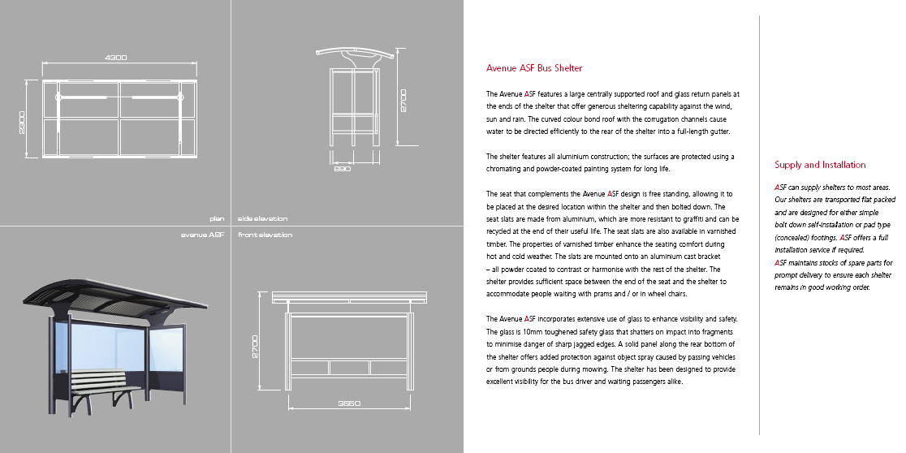

Some Good Websites:
- http://www.queensburyshelters.co.uk/urban-shelters.asp
- http://www.garrickoutdoor.org.uk/bus_shelters.php

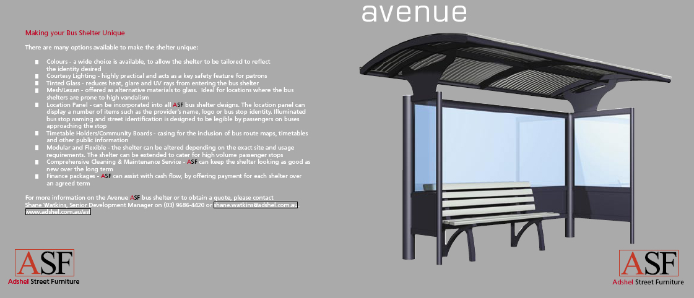

Some Good Websites:
- http://www.shelterstore.co.uk/
- http://www.e-cantonfair.com/products/modern-bus-shelter-511593.html

