Design Crafts – Street Furniture

Your design company has been asked to produce a range of ideas for bollards to be used throughout Harchester to close a number of roads and protect a range of pedestrianized areas. However, these ideas need to be presented in three different Medias, one in perspective, one using CAD and final through the medium of models.

This is a pure design exercise to understand how you can generate ideas through a range of approaches.

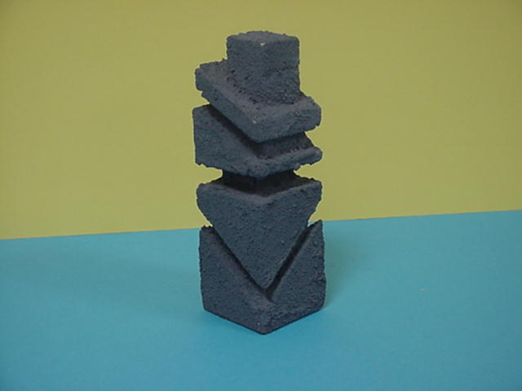
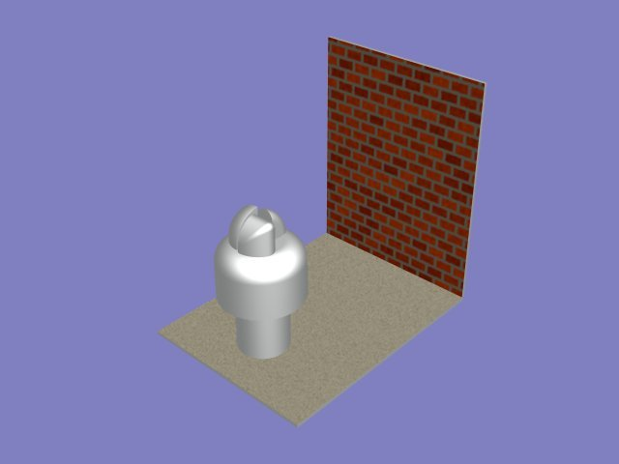
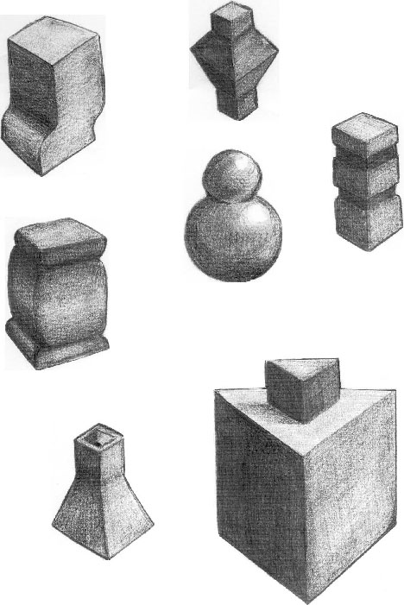

Websites:
https://www.bollards.co.uk/ - Street Furniture supplier

http://www.furnitubes.com/street-furniture/bollards - Street Furniture supplier

http://www.logicstreetfurniture.co.uk/ - Street Furniture supplier

http://www.langleydesign.co.uk/ - Street Furniture supplier

CLIENT:
Harchester Council

TASK:
You will need to produce a range of concept models of street furniture

OUTCOMES:
- A range of annotated ideas to be presented to the council, in a form of your choice. Portfolio of work to support the project.
- A range of scale concept models, which will show a range of possibilities.

RESOURCES:

- DT Library, School Website BTEC Section
- 2D Design, Photoshop, Sketchup
- Design Studio, ICT Suite, Workshops

