Task 4.2 – Bus Shelter

INTRODUCTION/SCENARIO:
You have also been approached by the council with the support of the local bus company to design a series of new bus shelters for the town to go around Harchester at key points. This is being paid for by both the Council and the local bus company and is included as part of the relocation of the central depot and the new park & ride scheme.

CLIENT:
Harchester Council and Harchester Bus Company

TASK:
You will need to produce a range of ideas and a scaled model of your chosen design to show the Council as planning permission may need to be sorted.

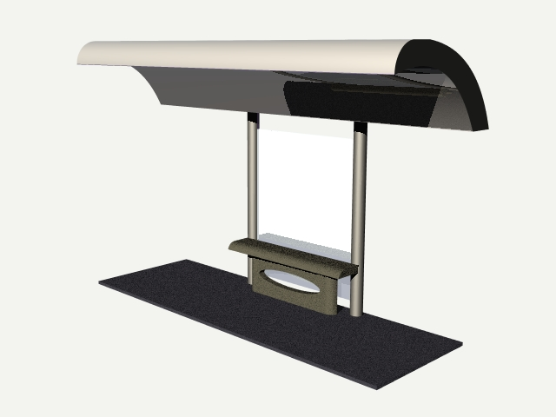
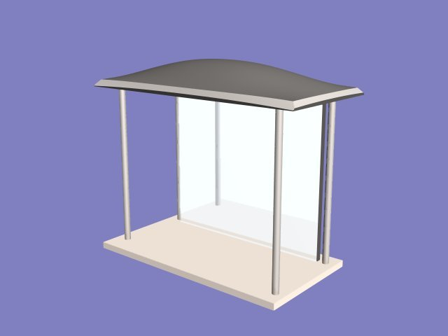

OUTCOMES:

A range of ideas to be presented to the council and bus company in a form of your choice
A scale model of the design that you feel is the best option.

EVIDENCE YOU MUST PRODUCE FOR THIS TASK

Portfolio containing:
- records of relevant research to inform the design
- progress journal – your ideas (how could you make a bus shelter more interactive or interesting?, using what you have learnt from your research)
- annotation – what skills, materials, techniques, process have been used and what messages are being communicated?
Final Model:
- Made to scale, accurate model using a variety of materials

