Litter Bin Manufacture
Plastic
Injection Moulding
This is the main process used to make complex plastic items, the moulds are expensive and can be more than the machine as they have to resist the pressure of the plastic being injected into them which can be up to 50,000lbs
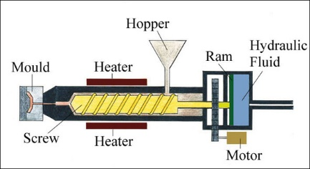

Rotational Moulding
Rotational moulding is a process that is ideal for the moulding of hollow products. These include tanks holding liquids, flower pots, rainwater tanks, footballs, road cones, fenders, luggage trays. Polyethylene and Polypropylene are ideal polymers for this moulding process. It is particularly suitable for the manufacture of batches from 100 to 5000 units. The mould are cheap to make as normal steel or aluminium can be used.
Rotational moulding is a four stage process.
1. The mould opens and is filled with powdered polyethylene or polypropylene and closed. The moulds are usually manufactured from aluminium, on CNC machines.
2. The mould moves to the next stage, where it is heated to 300oC. At the same time the mould rotates so that the powder is forced against the wall of the mould.
3. The mould moves onto the cooling stage. Cool air is blown around the mould, aided by large fans. The mould cools slowly and solidifies. The finished product is then removed.
Metal
Casting
Cast iron is a ferrous metal which has been heated until it liquefies at around 1200oC, and is then poured into a mould to solidify. It is usually made from pig iron.
Welding
There are mainly different types of welding, for many types of metal and purposes. It is fairly automated at the basic level, but requires high level of skill at the top range. Stainless steel is welded by MIG welding. Galvanised steel can give off dangerous fumes when welded

Further Reference – www.technologystudent .com

