Task 4.1 – Litter Bin

INTRODUCTION/SCENARIO:
It has been agreed by Harchester Council to invest in a new approach in ensuring that the town is kept clean. This is very important to them as they wish visitors to get a good impression. Part of the project is to replace the existing set of litter bins with a new range. The main area around the central zone will have their bins emptied quickly. It is intended to use a small fleet of dustcarts, the size of a small van, to undertake the task and shop waste will be emptied at night by the same fleet. The Council intends to pave areas within the town to help and make create people friendly zones

CLIENT:
Harchester Council

TASK:
To design and make a range of litter bins which will reflect the new and modern style of Harchester. They will be free-standing and they will have a liner which will be made of galvanised steel and which can be removed quickly. Any material can be used for the main body if you feel it is appropriate. It is advised that you look at some existing products.
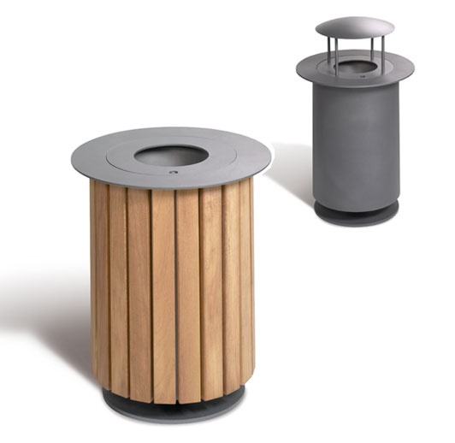
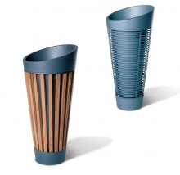

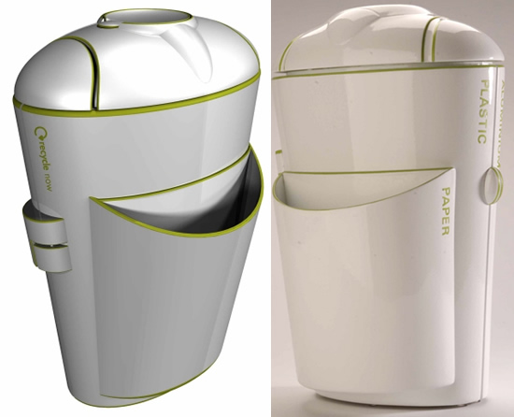

OUTCOMES:

- A portfolio which deals with the production of the product
- A scale model, which shows the possibilities for the product.

EVIDENCE YOU MUST PRODUCE FOR THIS TASK

Portfolio containing:
- records of relevant production details and H&S issues
- progress journal of the construction and the products evolution
- annotation – what skills, materials, techniques, process have been used, what technical information has been explored
Final Model:
- Made to scale, accurate model using a variety of materials

